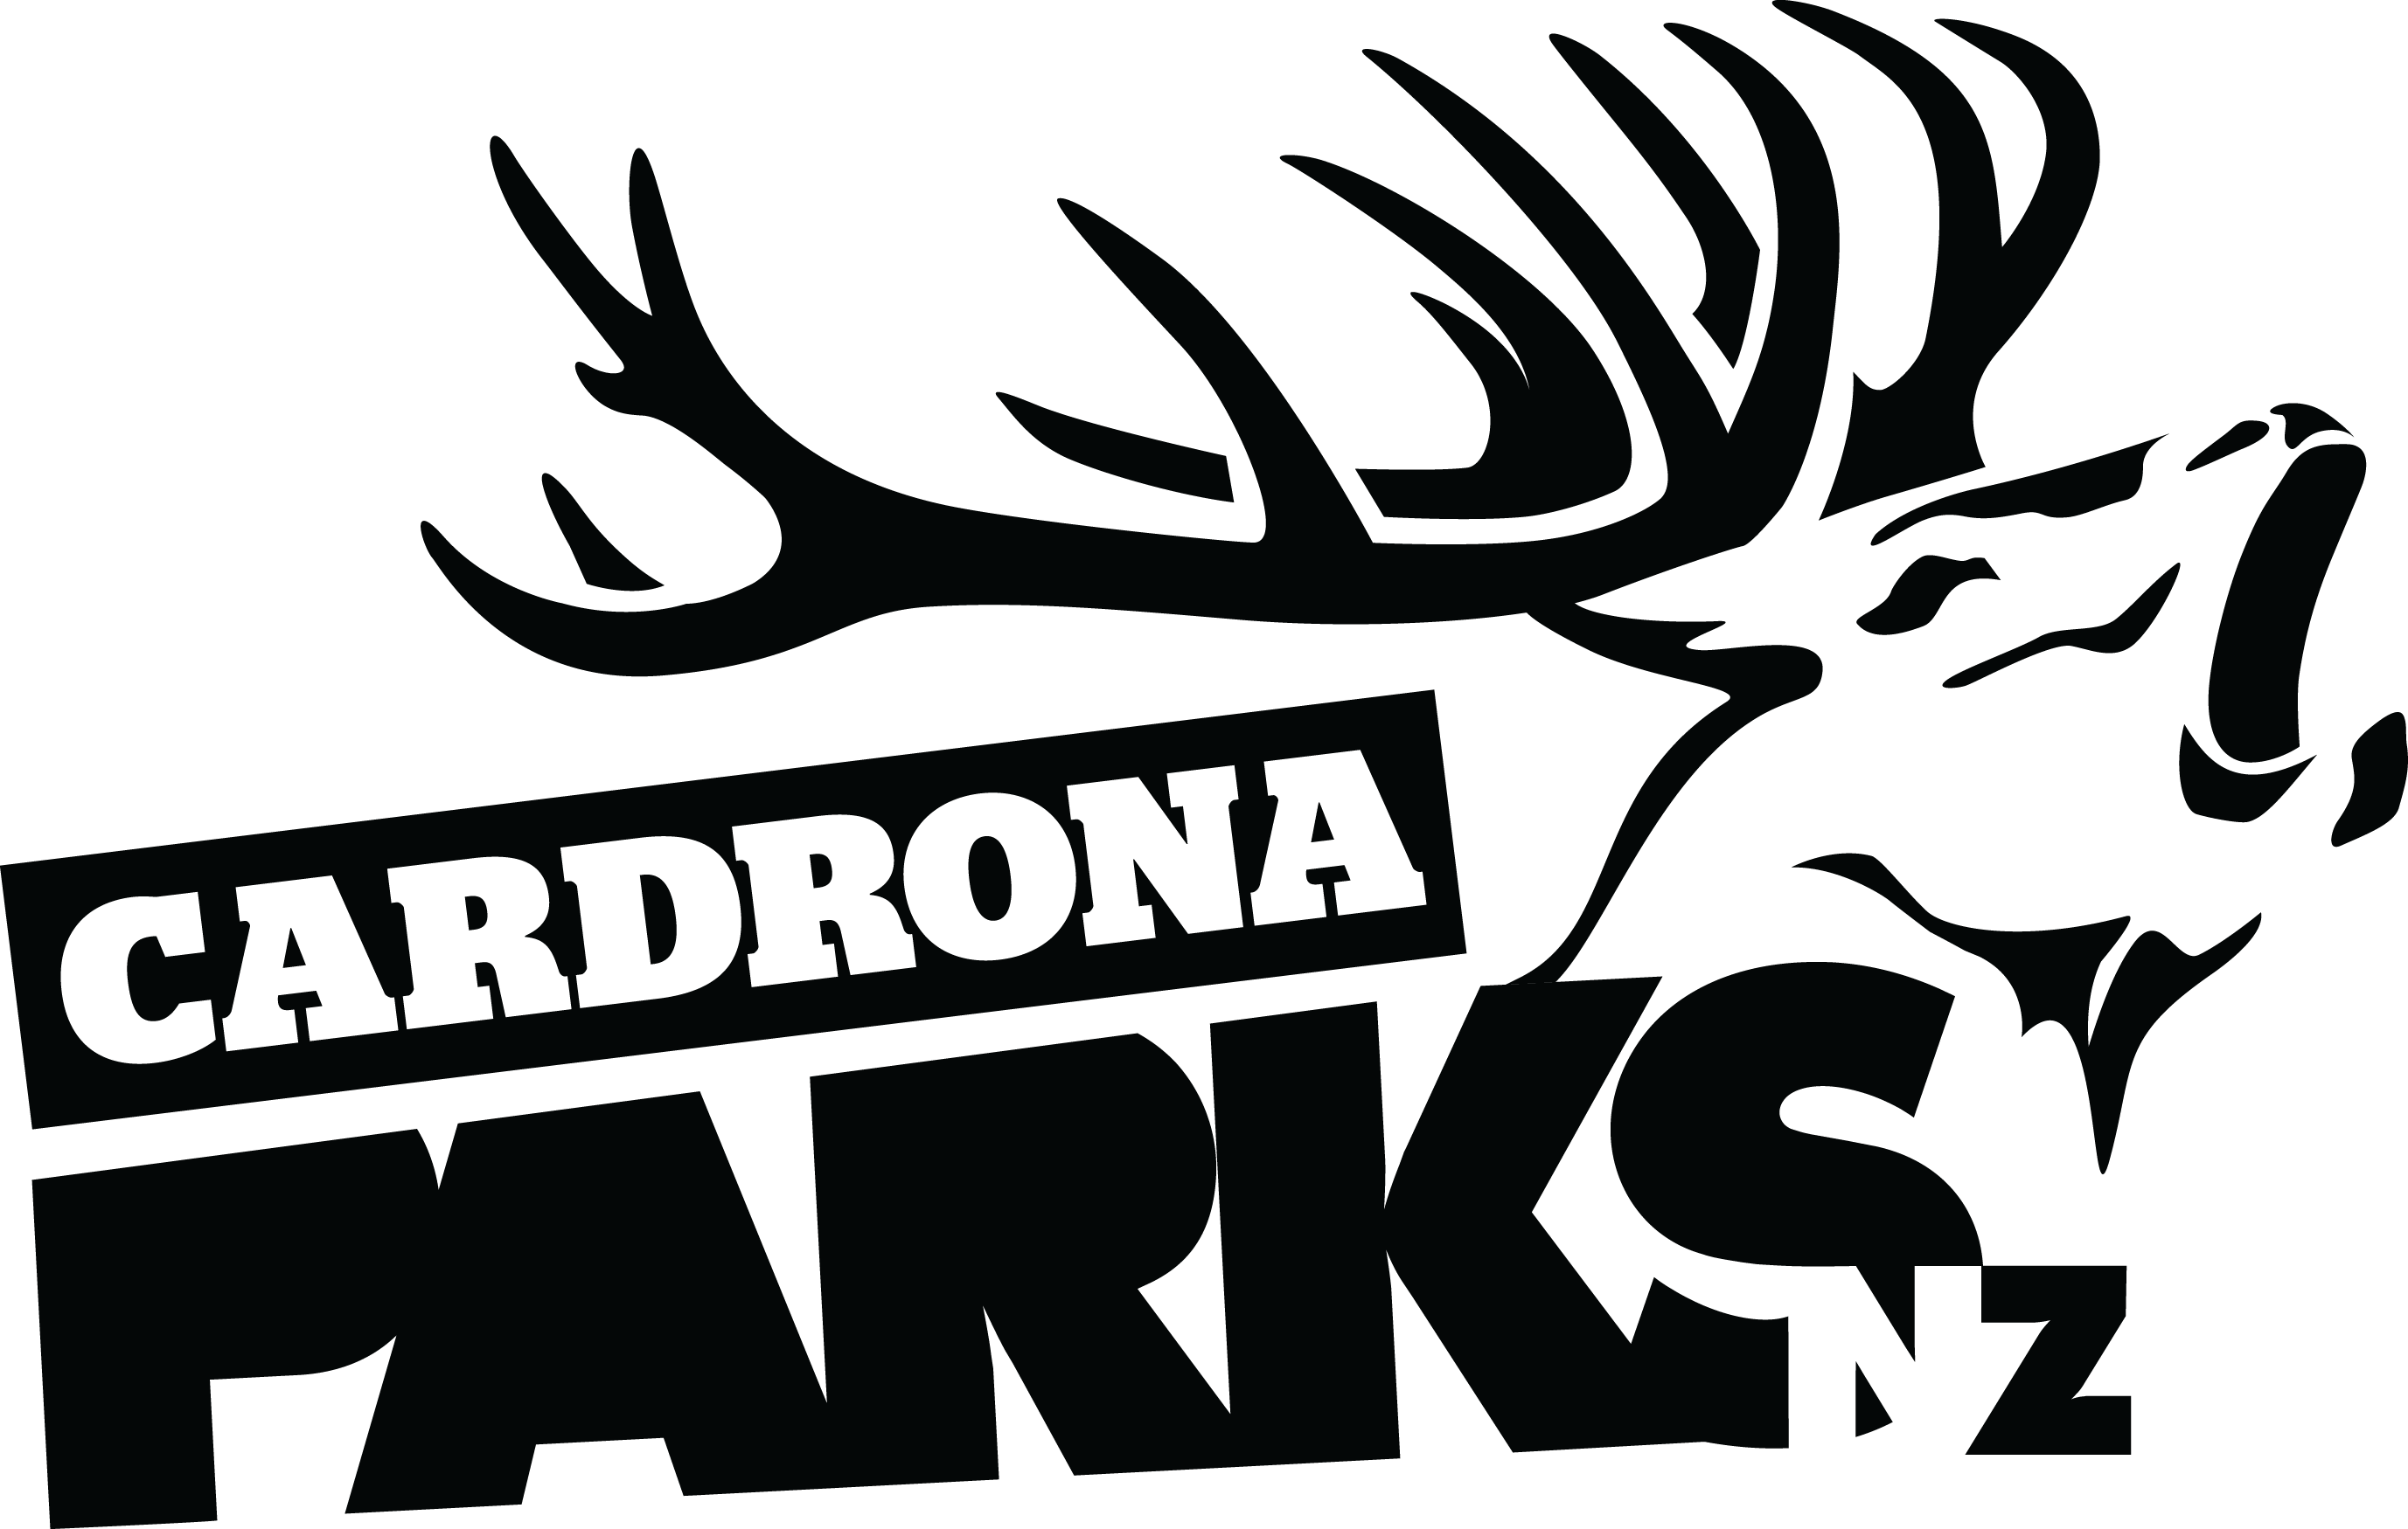

FOR IMMEDIATE RELEASE:
Cardrona Alpine Resort
Wanaka, NZ
August 16, 2018

RE: NEW ADVANCED TERRAIN & LIFT TO BE INSTALLED AT CARDRONA FOR WINTER 2019

Summer 2019 is set to be another busy one of developments up at Cardrona Alpine Resort, with today’s announcement of a new lift, accessing advanced terrain, to be installed in the “Pringles” area of the resort.
Pringles offers 55ha of new advanced, technical terrain. The Pringles Quad chairlift will be installed in the basin directly below Captain’s Express and above Pringles Creek, with the top station just above Captain’s Pizzeria.
The new Pringles Quad will be the upgraded, repurposed McDougall’s Quad, which was removed in 2016/17 to make way for New Zealand’s first gondola lift on a ski area, the McDougall’s Chondola.
The Pringles terrain will include a main intermediate trail, a series of expert and advanced chutes, and a trail that extends all the way around the front of the mountain to the base of Valley View Quad.
It also opens up the terrain directly beside Captain’s Basin, which has always had a challenging exit to get back to the bottom of Captain’s Express. Secret Chutes are a local’s favourite which will be a welcome addition to Cardrona’s lift-accessed terrain.
“We’re so stoked to be able to offer some of the more advanced terrain our people have been asking for next winter,” says Cardrona’s General Manager, Bridget Legnavsky.
“The terrain on offer with Pringles is unlike anything we offer at Cardrona at the moment.”
Pringles has a southerly-facing aspect, with reliable snow conditions throughout the New Zealand winter season.
MORE
“We’ve been keeping an eye on that terrain for a long time now,” says Legnavsky. “The snow down there has looked consistently epic as we’ve monitored it for a couple of seasons, so we’re super excited to get to ski there soon!”
The new Pringles Quad will increase lift capacity at Cardrona from 5500 to 7000 skiers per hour, an increase of 20% total. The added capacity will take pressure off existing chairlifts, primarily Captain’s Express and Whitestar Express.
The ski trails will take Cardrona’s terrain percentages to 25% beginner, 25% intermediate, 25% advanced & 25% expert – making the mountain a playground for all levels of skiers and snowboarders.
Pringles adds 55ha of skiable terrain to Cardrona for next winter, taking Cardrona to 400ha of skiable terrain total. With the Soho Ski Area development over the next few years, the resort will more than double in terrain size to 900ha of skiable terrain, making Cardrona the largest single commercial ski area in New Zealand.
“It’s so important to us that everyone feels welcome at Cardrona, and that means building lifts and expanding into terrain that captures the imagination of our guests. We can’t wait to see how they make this new terrain their own,” says Legnavsky.
Construction on the existing McDougall’s Quad upgrade is already underway by lift company Doppelmayr. The install of the lift and trail work are due to begin in early 2019.
ENDS

Media Enquiries:
Bridget Legnavsky
General Manager
Cardrona Alpine Resort
bridget@cardrona.com
Phone +64 27 550 0818

About Cardrona Alpine Resort
Founded in 1980, Cardrona Alpine Resort is New Zealand’s most popular ski area, where everyone’s a VIP – from beginners & families, to Olympic & X Games athletes. Cardrona’s 3 vast basins are home to NZ’s first cabin-style lift – the McDougall’s Express Chondola & the Southern Hemisphere’s most extensive terrain parks & pipes. Wide, open trails offer some of NZ’s best snow conditions, thanks to high altitude & an innovative snow management system. Take an easy drive from Queenstown or Wanaka & be welcomed with genuine Kiwi hospitality.

In the summer months Cardrona is open for mountain biking, carting, conferences & other alpine adventure activities. Cardrona is a wholly-owned subsidiary of Real Journeys Ltd.

