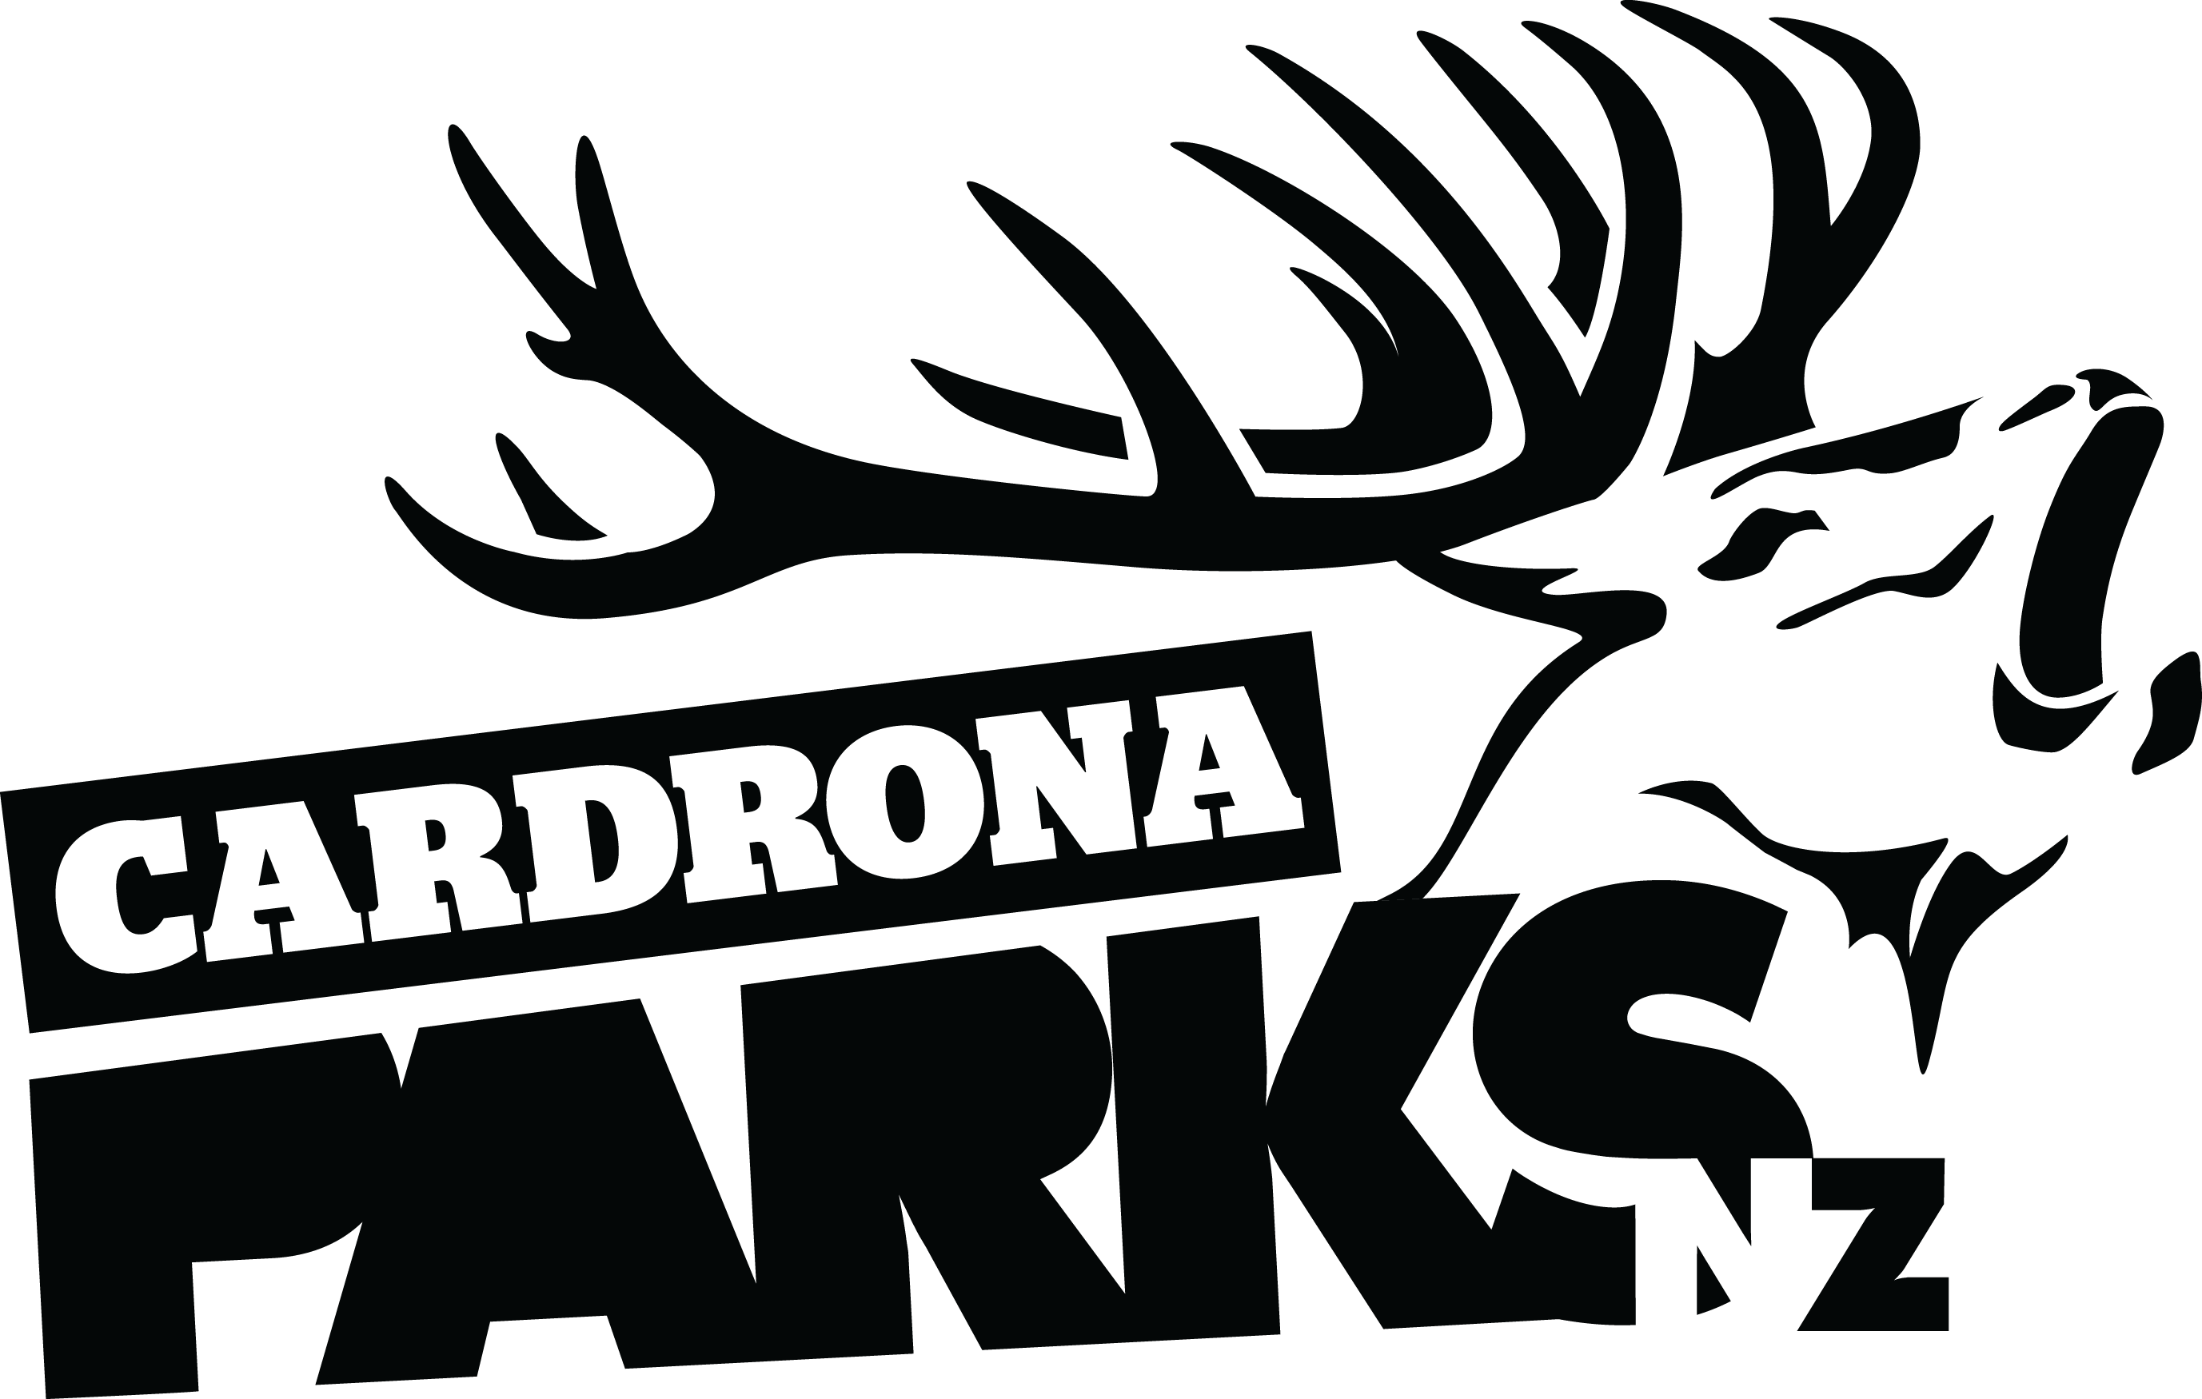

FOR IMMEDIATE RELEASE:
Cardrona Alpine Resort
Wanaka, NZ
July 12, 2018

NEW ZEALAND’S LARGEST ALPINE RESORT TO BE DEVELOPED BETWEEN QUEENSTOWN & WANAKA

A new partnership between Cardrona Alpine Resort and Queenstown businessman John Darby will lead to the development of New Zealand’s largest alpine resort, incorporating Cardrona and a new Soho Basin Ski Area.
Soho Basin faces Queenstown and covers all the southern and south-west faces of Mt Cardrona, and includes the two Willow Basins that directly adjoins Cardrona Alpine Resort’s southern boundary. Soho Basin will add an additional 500ha of high altitude skiable terrain, offering up to 500 vertical metres of skiing.
The Real Journeys Group, owner of Cardrona Alpine Resort, has committed to continue its investment programme into Cardrona. Development of the larger, integrated Cardrona-Soho Ski Area will be in accordance with the agreed masterplan for the combined ski areas.
“This has been something we’ve been looking at for some time and we’re both extremely pleased that we can work together to build a world class ski area with integrated facilities and amenities that will be both New Zealand’s largest mountain resort and a truly world-class ski destination,” says Real Journeys Group Chief Executive Richard Lauder.
This partnership will see Cardrona more than double in size to over 900ha of skiable terrain. Access to the Soho Ski Area will be from the top of the recently installed McDougall’s Chondola, with facility development at the top of the mountain to support this.
Soho Basin, as part of Glencoe Station, was first acquired by Darby over a decade ago.

MORE

“The diversity of the slopes in the Soho Basin make it an exceptional ski area for all levels of skiers. Its high altitude, southerly-facing aspect means it receives and retains a good cover of early snow. Soho’s offers spectacular views out over Queenstown, the Wakatipu Basin, and across the Main Divide,” says Mr Darby.
“I’ve skied Soho Basin with friends and family for now well over 20 fabulous winters seasons. With Cardrona, I’m now looking forward to opening up this same opportunity to the public. It’s a very special place and great care will be taken to preserve this wonderful alpine environment.”
“To be a truly world-class alpine resort, you need to have extensive lift networks, multiple aspects and varying terrain – this new terrain and the developments that go with it will really make Cardrona an extraordinary experience in Aotearoa,” says Cardrona General Manager, Bridget Legnavsky.
“We’re thrilled at this opportunity to continue creating epic experiences for all our people now, and into the future.”
Cardrona is three years into a five-year development plan that has focused on preparing Cardrona for the Soho expansion by improving guest flow & capacity. This has included installation of the McDougall’s Chondola to increase uplift, the refurbishment and repurposing of the Base Area buildings, and expanded carparking with a connecting shuttle service.
The expansion also has implications on Cardrona’s summer operations, with the opportunity to grow further as New Zealand’s only mountain resort to offer a full summer of activities including mountain biking, mountain carting, dining, events and stargazing experiences.
All necessary approvals are now in place to commence the staged development of ski area facilities in the Soho Basin and the development of the ski area and supporting facilities is expected to begin once the current Cardrona masterplan is completed. In the meantime, cat skiing will continue to be provided for those who wish to experience the Soho Basin before commercial ski operations are developed.
For more information on Cardrona Alpine Resort, visit www.cardrona.com. For more information on John Darby and the Soho Ski Area, visit www.darbypartners.com and www.sohobasin.com.
ENDS

Media Enquiries:
Bridget Legnavsky
General Manager
Cardrona Alpine Resort
bridget@cardrona.com
Phone +64 27 550 0818
About Cardrona Alpine Resort
Founded in 1980, Cardrona Alpine Resort is New Zealand’s most popular ski area, where everyone’s a VIP – from beginners & families, to Olympic & X Games athletes. Cardrona’s 3 vast basins are home to NZ’s first cabin-style lift – the McDougall’s Express Chondola & the Southern Hemisphere’s most extensive terrain parks & pipes. Wide, open trails offer some of NZ’s best snow conditions, thanks to high altitude & an innovative snow management system. Take an easy drive from Queenstown or Wanaka & be welcomed with genuine Kiwi hospitality. Cardrona holds Qualmark Gold for the resort & Gold 3+ stars for its apartments, recognised as one of the best sustainable tourism businesses in New Zealand.

In the summer months Cardrona is open for mountain biking, carting, conferences & other alpine adventure activities. Cardrona is a wholly-owned subsidiary of Real Journeys Ltd.

