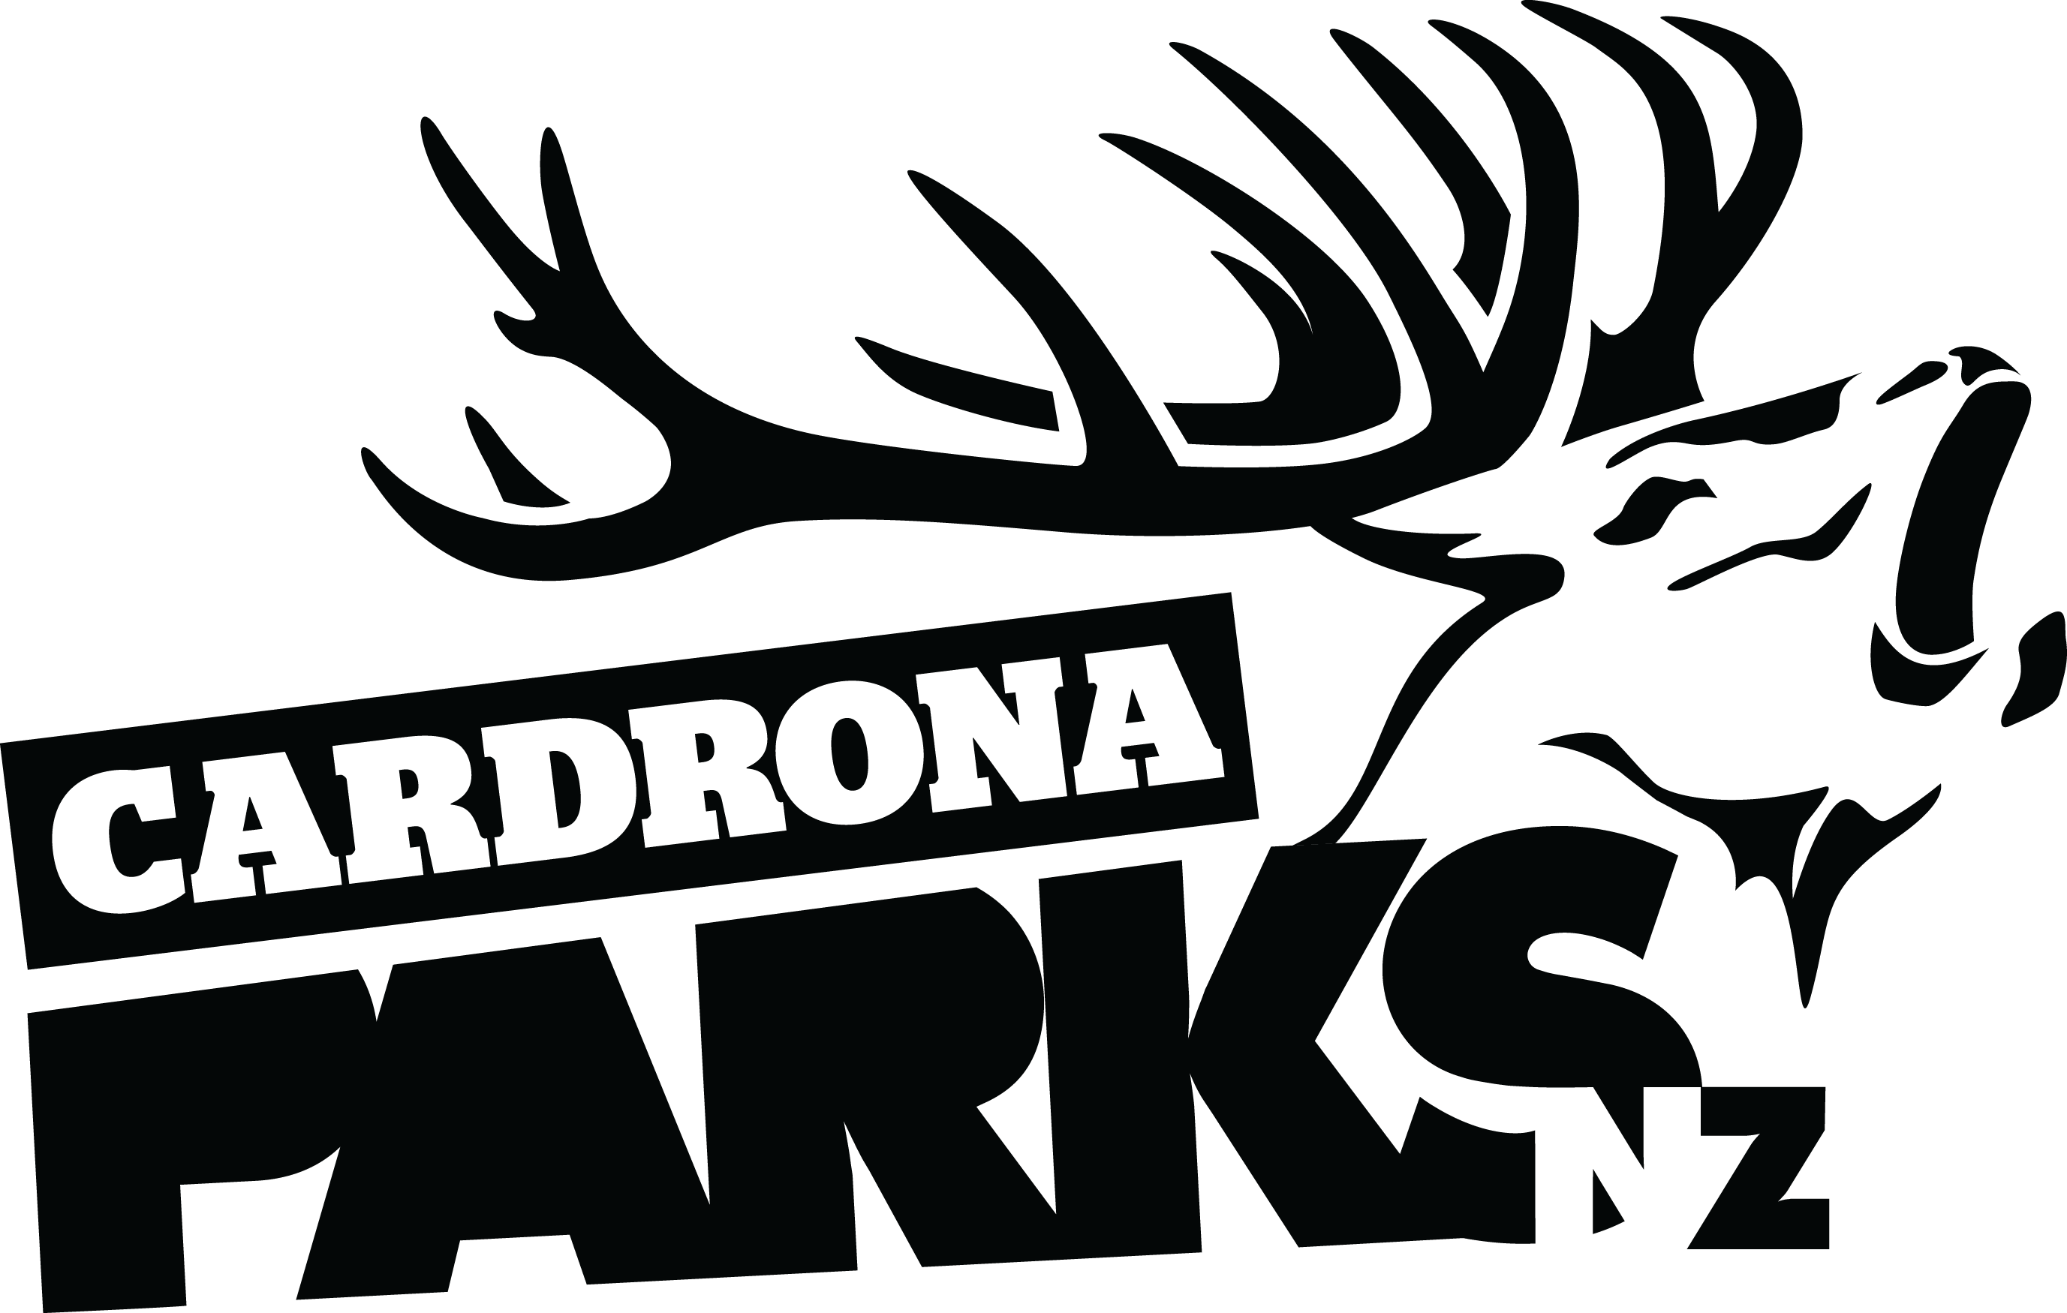
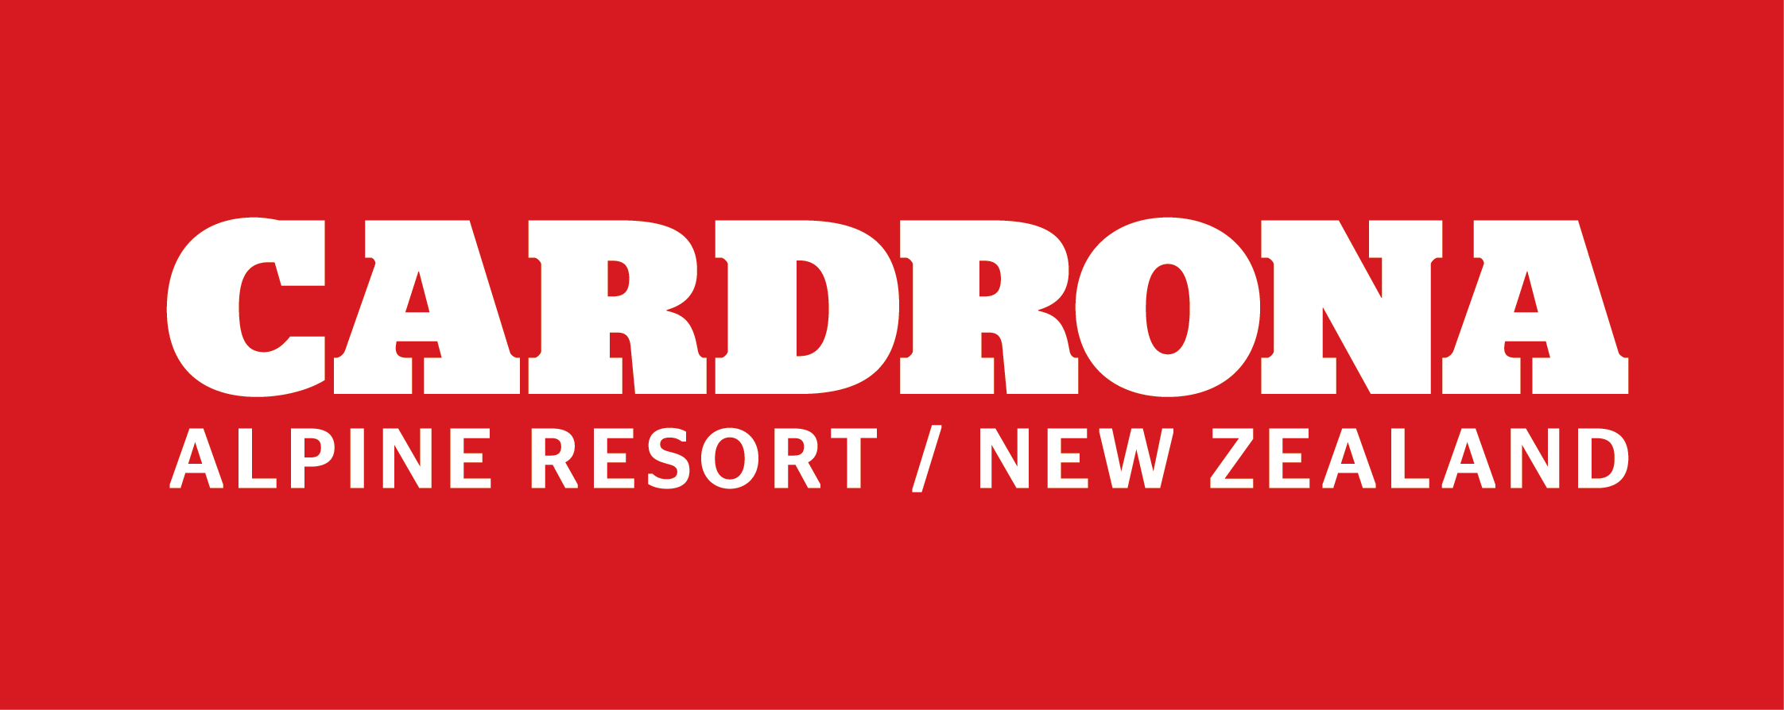

FOR IMMEDIATE RELEASE:
Cardrona Alpine Resort
Wanaka, NZ
May 28, 2018

RE: PRE-SEASON TEASER - CARDRONA ALPINE RESORT TO OPEN THIS WEEKEND

To celebrate a 90cm snow base, Cardrona Alpine Resort is opening for skiing and snowboarding this coming weekend in a pre-season teaser before official Opening Day on June 16.
Last week Cardrona received over 90cm of natural snow, with cool temperatures allowing the resort’s snowmaking team to make significant amounts of snow on top of that total. The snowfall from last week was the latest in a string of storms this year, with large snowfalls on the mountain every month in 2018 except for January.
The McDougall’s Chondola, the Beginners’ Area and The Lounge will be open from 8.30am through till 4pm both weekend days, weather-dependent. Lessons and rentals will also be available.
“We’re so stoked to share this early snowfall with everyone in the region this weekend by opening for a couple of days pre-season,” says Cardrona General Manager, Bridget Legnavsky.
“We’ve been absolutely frothing to get out skiing and snowboarding when it’s looking this good – and it’s amazing to be able to bring all our guests up to get their fix too.”
After the weekend’s skiing and snowboarding, the resort will resume preparations for the official Opening Day on June 16. This includes completion of the Base Café and Mezz renovations, and staff training for over 600 staff who are due to arrive on June 11.
Guests with season passes are encouraged to pick up their RFID cards from the Wanaka or Queenstown offices before Saturday. Day passes will be available for purchase in advance from 20 Helwick St, Wanaka and 37 Camp St, Queenstown, as well as on-mountain on Saturday and Sunday.
ENDS

Media Enquiries:
Bridget Legnavsky
General Manager
Cardrona Alpine Resort
bridget@cardrona.com
Phone +64 27 550 0818

About Cardrona Alpine Resort
Founded in 1980, Cardrona Alpine Resort is New Zealand’s most popular ski area, where everyone’s a VIP – from beginners & families, to Olympic & X Games athletes. Cardrona’s 3 vast basins are home to NZ’s first cabin-style lift – the McDougall’s Express Chondola & the Southern Hemisphere’s most extensive terrain parks & pipes. Wide, open trails offer some of NZ’s best snow conditions, thanks to high altitude & an innovative snow management system. Take an easy drive from Queenstown or Wanaka & be welcomed with genuine Kiwi hospitality.

In the summer months Cardrona is open for mountain biking, carting, conferences & other alpine adventure activities. Cardrona is a wholly-owned subsidiary of Real Journeys Ltd.

