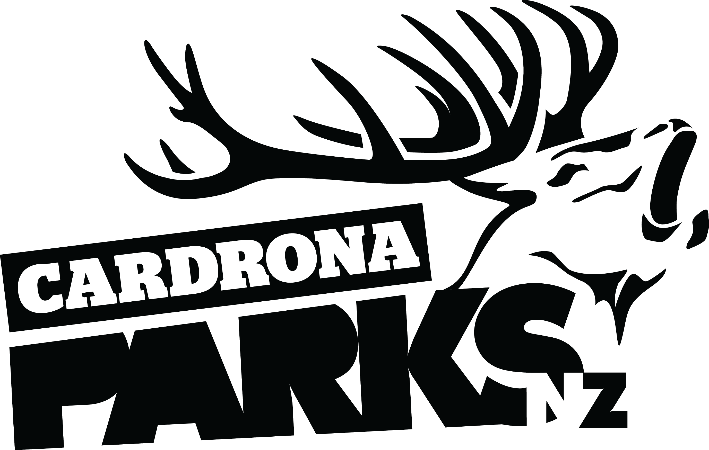
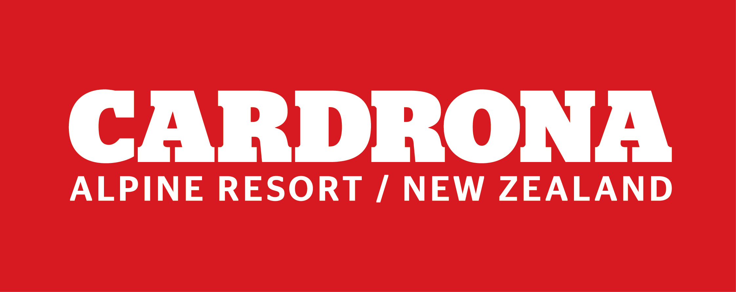

FOR IMMEDIATE RELEASE:
Cardrona Alpine Resort
Wanaka, NZ
March 6, 2017

RE: OVER $15M IN DEVELOPMENTS FOR WINTER 2017 AT CARDRONA ALPINE RESORT

Developments for the 2017 winter season at Cardrona have totalled over $15million, with continued investment in the resort’s facilities and infrastructure. The investment includes a new high speed cabin lift, Base facility development, and improvements in terrain, carparking and snowmaking.
The biggest development for Winter 2017 is the new McDougall’s Express Chondola. The Doppelmayr “combined” lift of eight-person gondola cabins and six-seater chairs will replace the old McDougall’s Quad Chair. It is the first cabin-style lift on any ski area in New Zealand.
The McDougall’s Chondola will increase the lift’s capacity by 150%, with an hourly uplift of 2,550 skiers, snowboarders and sightseers.
With the goal of leaving the Mt Cardrona landscape and topsoil in better condition than when construction began, one of the project targets is to have no more than one skip bin full of waste. The lift construction project is being reviewed within the Infrastructure Sustainability Council of Australia’s rating scheme,
“We are so excited that this new lift will get people of all abilities to the top of the mountain and that we’re leaving our maunga better than before the project,” says Cardrona’s General Manager, Bridget Legnavsky.
“We’re all about fun, but it has to be sustainable – that’s something we’re working towards and really proud of.”

MORE
Building on Cardrona’s excellent children’s facilities, is an over $1 million building expansion and redesign of Cardrona’s Ski Kindy. The Kids’ Snow Sports School will be moving into the same building, Snow Sports HQ, giving parents one central location for all their children’s on-mountain education and care. With this development, Snow Sports HQ is now ski-in/ski-out on all three levels.
Also new for Winter 2017 is a new slope-side café and bar in the Base area – The Lounge. It will serve freshly-made food with local ingredients daily, and boasts a range of craft beers and the full Real Journeys, intensively-scrutinised and hand-selected wine list.
This year, Cardrona is adding more spaces to the Valley View carpark so even more pass holders can access the mountain from the resort’s lowest lift. This allows guests to cut ten minutes off the drive, get a coffee at the new Little Meg Café, then ride Valley View Quad to access the mountain.
The resort also continues to invest in snowmaking facilities, with improved water collection systems for the 2017 winter. The improved facilities increase snow reliability, which has meant the resort’s season can be extended by another week, with scheduled closing on October 15.
“With $15 million of developments and a season stacked with events like the Audi quattro Winter Games NZ and the Jossi Wells Invitational, it’s set to be a really exciting season at Cardrona,” says Legnavsky.
Cardrona’s season pass sale runs until March 31. For more information, visit cardrona.com.
ENDS

Media Enquiries:
Bridget Legnavsky
General Manager
Cardrona Alpine Resort
bridget@cardrona.com
Phone +64 27 550 0818

About Cardrona Alpine Resort
Founded in 1980, Cardrona Alpine Resort is New Zealand’s most popular ski area, where everyone’s a VIP – from beginners & families, to Olympic & X Games athletes. Cardrona’s 3 vast basins are home to NZ’s first cabin-style lift – the McDougall’s Express Chondola & the Southern Hemisphere’s most extensive terrain parks & pipes. Wide, open trails offer some of NZ’s best snow conditions, thanks to high altitude & an innovative snow management system. Take an easy drive from Queenstown or Wanaka & be welcomed with genuine Kiwi hospitality.

In the summer months Cardrona is open for mountain biking, carting, conferences & other alpine adventure activities. Cardrona is a wholly-owned subsidiary of Real Journeys Ltd.

