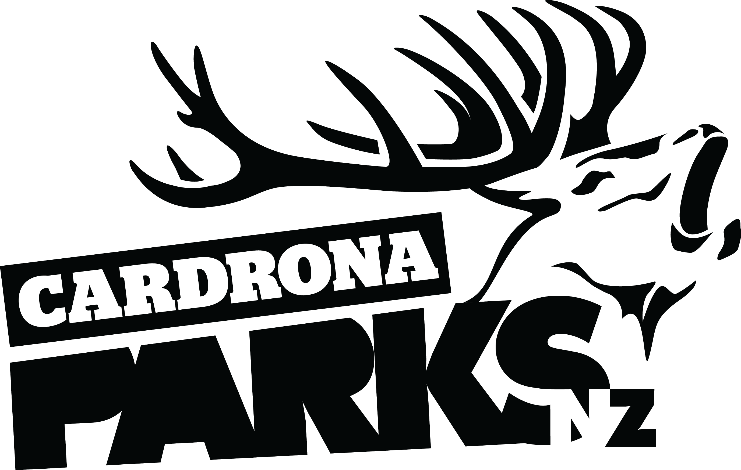
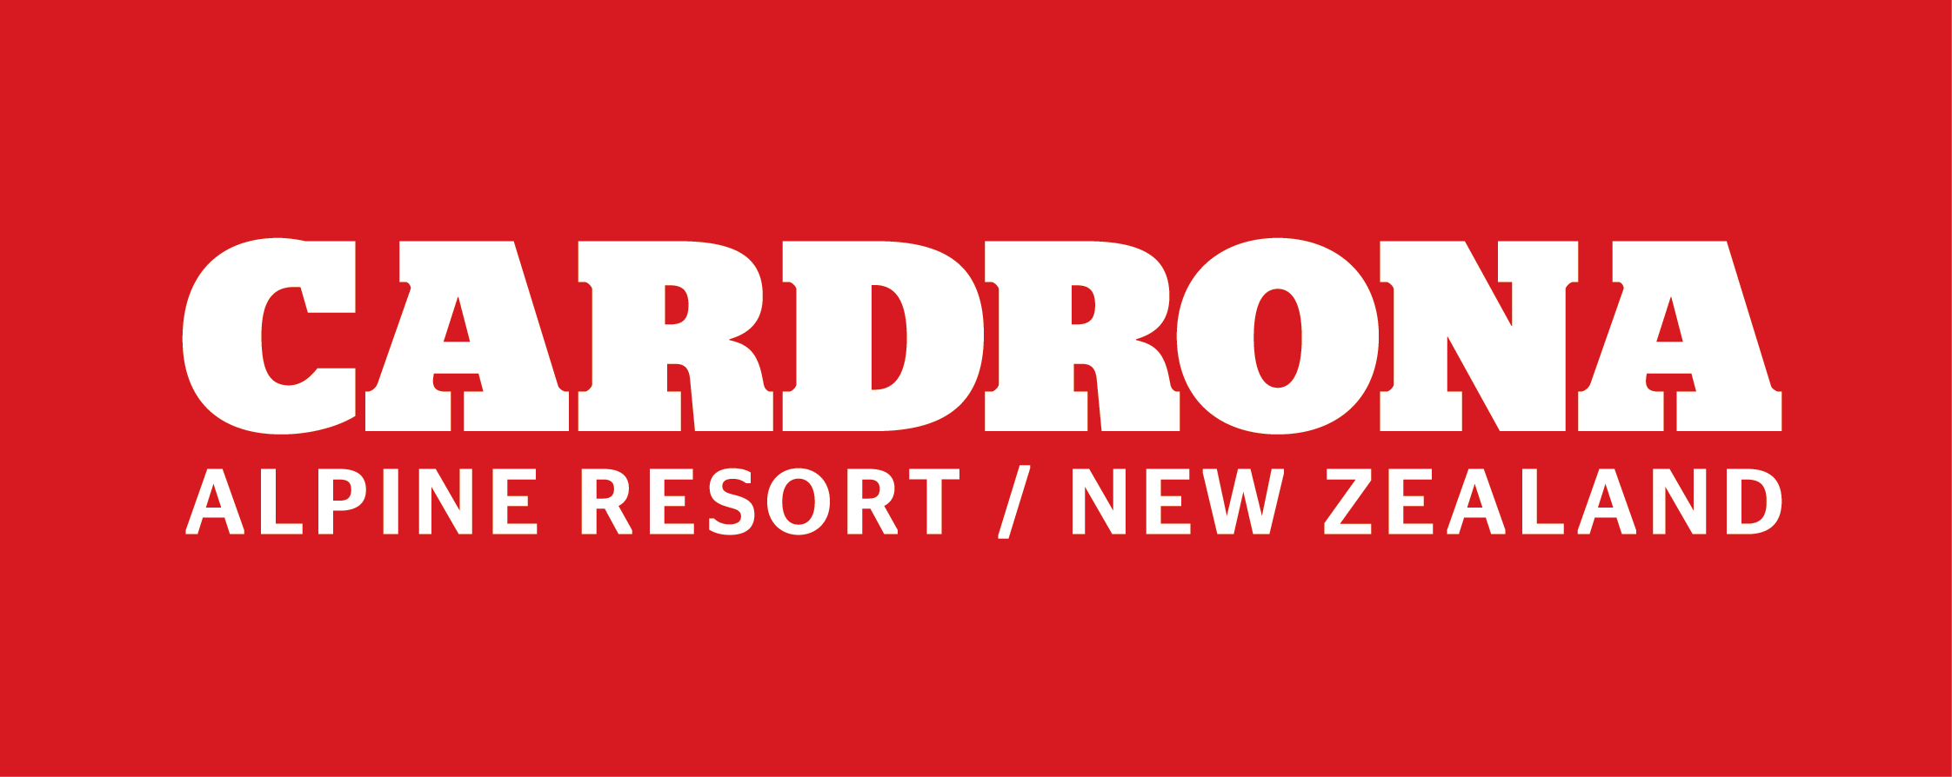

FOR IMMEDIATE RELEASE:
Cardrona Alpine Resort
Wanaka, NZ
April 1, 2017

RE: GOLD STRUCK AT CARDRONA DURING CHONDOLA CONSTRUCTION
A gold nugget has been discovered at Cardrona Alpine Resort, between Queenstown and Wanaka, during the construction of New Zealand’s first cabin-style lift on a ski area – the McDougall’s Express Chondola.
The nugget weighs 3.1kg – the heaviest gold nugget ever found in New Zealand, breaking a record that has stood since 1909 when Messers Scott and Sharpe found a 3.09kg nugget on the West Coast.
Gold is currently priced at NZD$1746.25 per oz, valuing this nugget at around NZD$190,000.
The Chondola construction was halted late Thursday afternoon, when Cardrona staff member Dave Collett discovered the gold nugget when operating a digger.
“I was helping the boys dig the trench up to the top of the new lift and saw the shimmer. I couldn’t believe it. I’ve worked here for 25 years and never seen anything like this,” says Collett.
Staff remain sceptical that there is more gold to be found on the mountain, deciding to continue with their winter season preparations instead of mining the alpine resort. Despite the delay from the discovery, the Chondola construction project is running ahead of schedule.
“Even if there is more up here, the real gold at Cardrona is our people,” says Cardrona’s General Manager, Bridget Legnavsky.
“We wouldn’t trade them in for all the gold in the world.”
The Central Otago Gold Rush in the 1860s was the last time any significant gold was found in the Cardrona Valley. The Rush made Cardrona a bustling town, which deteriorated as gold dried up.
To this day, gold mining references are still found on Cardrona Alpine Resort. Whitestar Express is named after a mining dredge, McDougall’s Chondola is named after the proprietor of the General Store in the 1800s, and Gin & Raspberry (a ski run) was the drink shouted by a mine owner when an ounce of gold was yielded.
So what will the money be spent on? No doubt it will go towards the resort’s developments. But first? A round of Gin & Raspberry.
ENDS
Media Enquiries:
Bridget Legnavsky
General Manager
Cardrona Alpine Resort
bridget@cardrona.com
Phone +64 27 550 0818
About Cardrona Alpine Resort
Founded in 1980, Cardrona Alpine Resort is New Zealand’s most popular ski area, where everyone’s a VIP – from beginners & families, to Olympic & X Games athletes. Cardrona’s 3 vast basins are home to NZ’s first cabin-style lift – the McDougall’s Express Chondola & the Southern Hemisphere’s most extensive terrain parks & pipes. Wide, open trails offer some of NZ’s best snow conditions, thanks to high altitude & an innovative snow management system. Take an easy drive from Queenstown or Wanaka & be welcomed with genuine Kiwi hospitality.

In the summer months Cardrona is open for mountain biking, carting, conferences & other alpine adventure activities. Cardrona is a wholly-owned subsidiary of Real Journeys Ltd.

