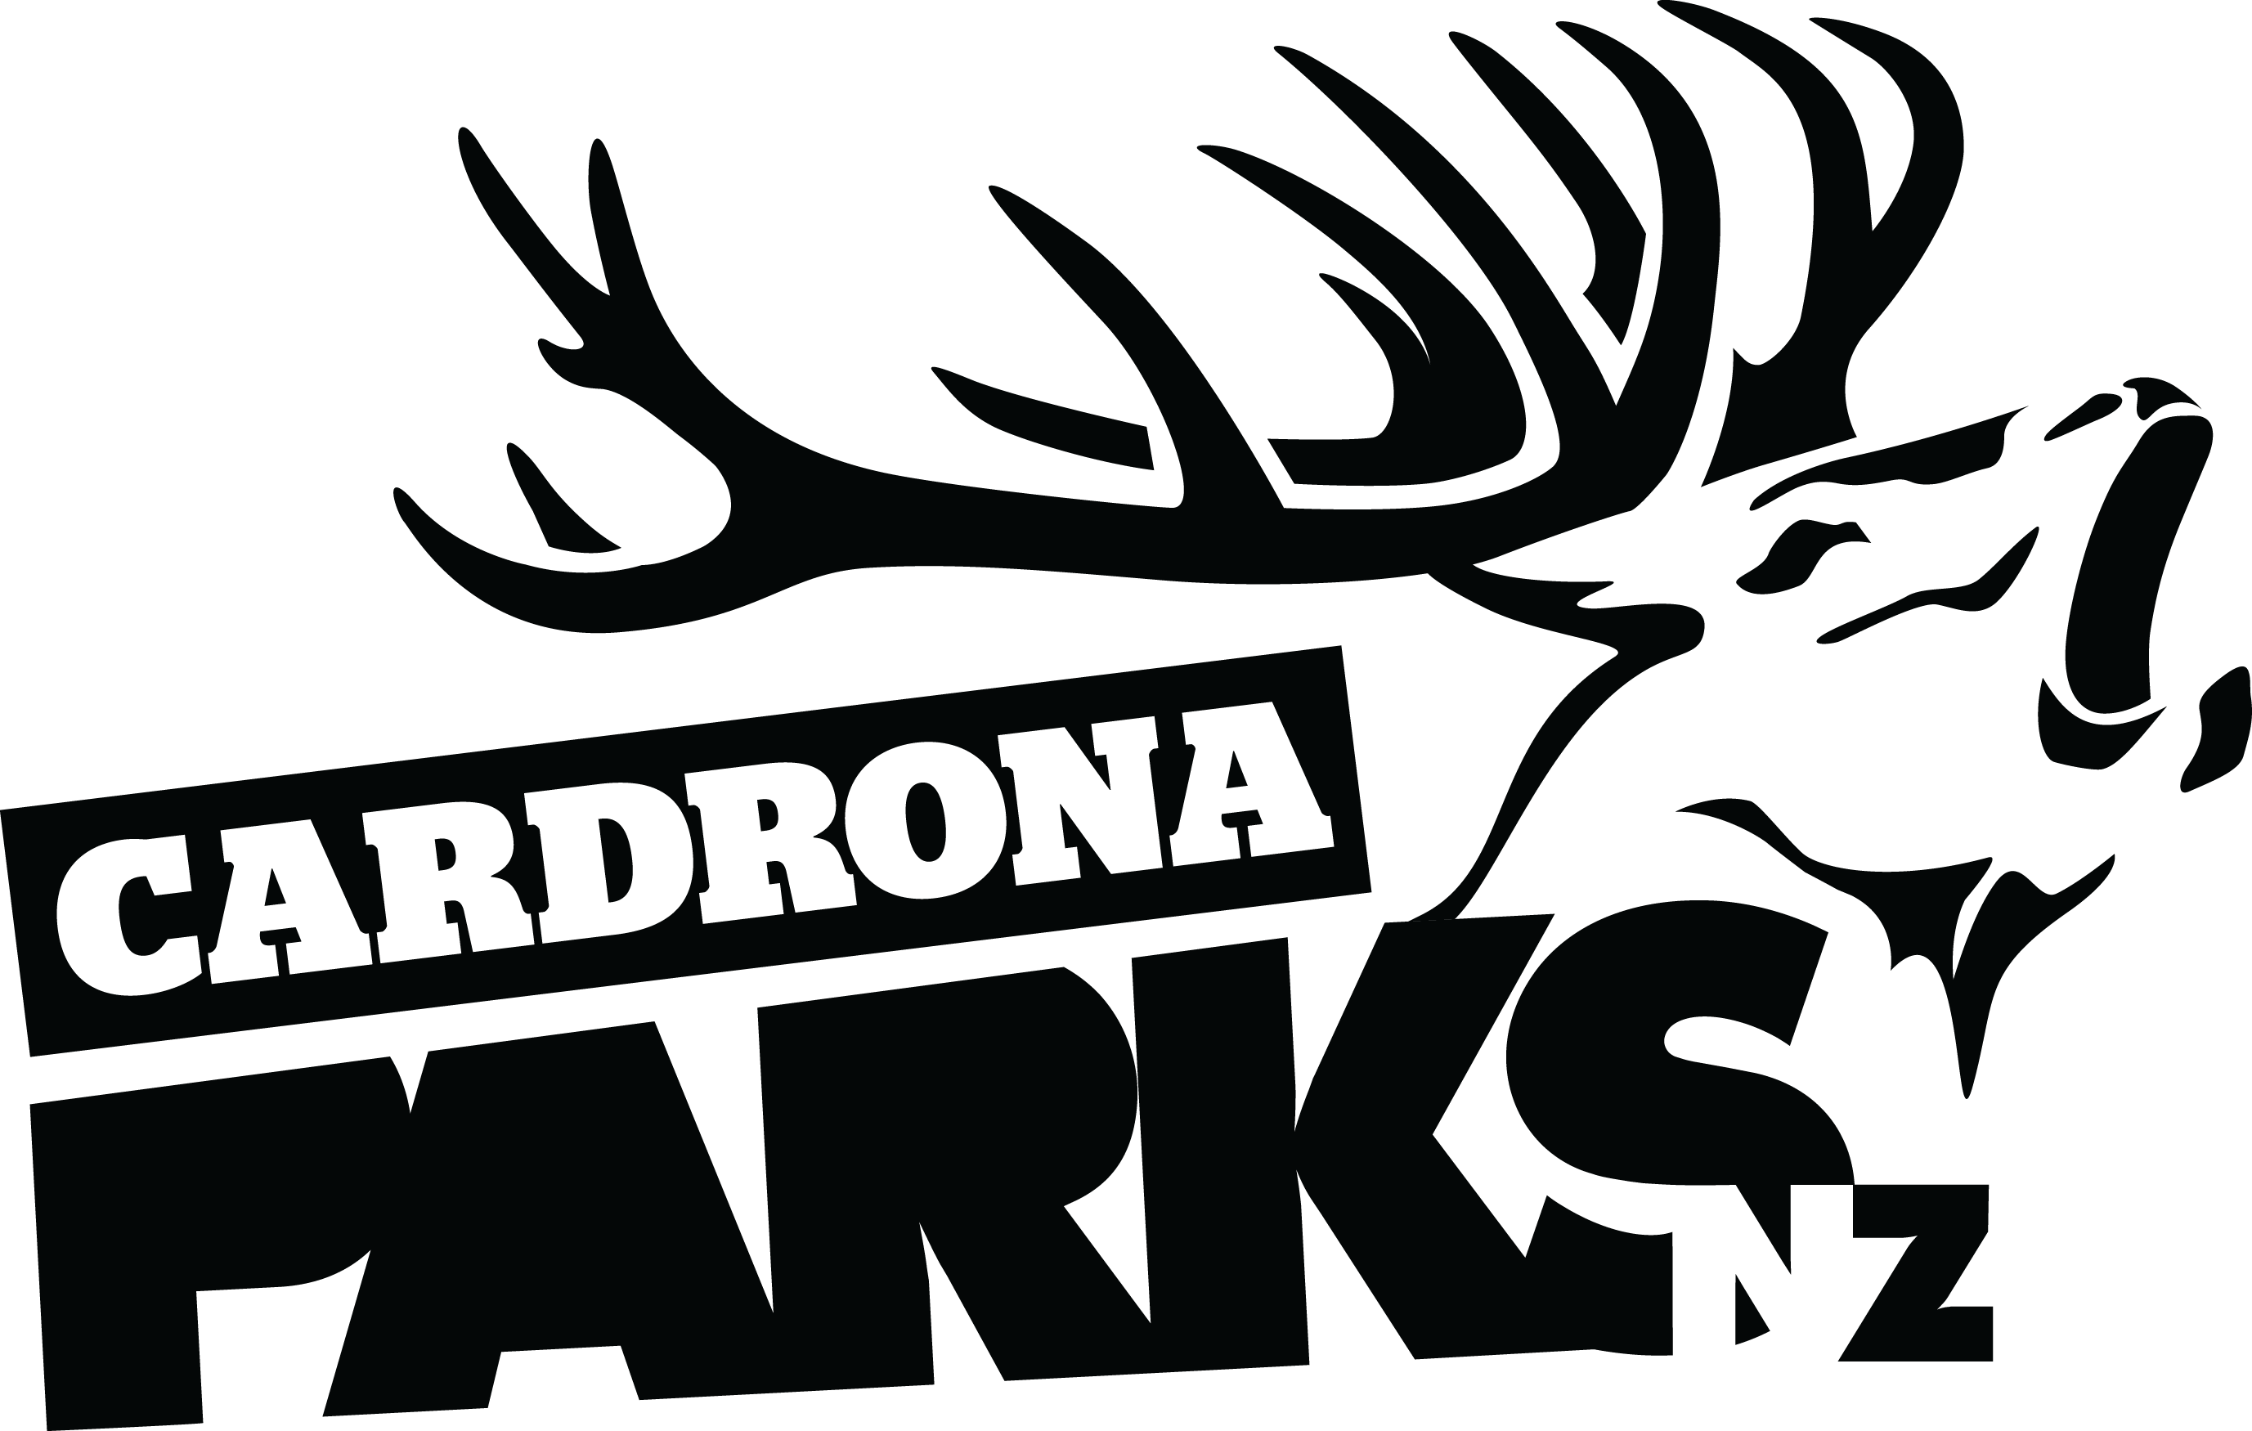
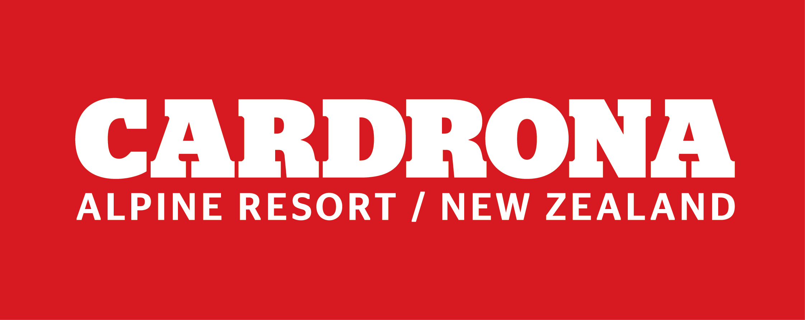

FOR IMMEDIATE RELEASE:
Cardrona Alpine Resort
Wanaka, NZ
June 10, 2017

RE: CARDRONA OPENS NZ’S FIRST CHONDOLA

Cardrona Alpine Resort has opened with a bang for Winter 2017, with more than 1000 skiers, snowboarders and sightseers riding the new McDougall’s Chondola for the very first time. The McDougall’s Chondola is New Zealand’s first cabin-style lift on a ski area, with a combination of six-seater chairs and 8-seater gondola cabins on the same lift.
The official Chondola Opening Ceremony began at 8.45am, with a karakia from Kaumatua Bubba Thompson, followed by a haka by the Mount Aspiring College kapa haka group. QLDC Mayor Jim Boult and X Games gold medallist Jossi Wells opened the cabins & chairs respectively in a ribbon cutting ceremony, and early guests were greeted with a glass of Mumm champagne.
The first chondola cabin ride was donated to the Tawaki Project, a scientific research project to learn more about the Tawaki (Fiordland Crested) Penguin – the third rarest penguin in the world. Scientist Thomas Mattern and his family joined Cardrona mascot Pengi, Real Journeys CEO Richard Lauder, and Jim Boult in the first cabin.
First chair rights were won by a group of local Wanaka youngsters, including Cardrona Grom Team members Finley Melville-Ives, Campbell Melville-Ives and Rocco Jamieson. The five keen skiers and snowboarders, who queued from 5.30am this morning, joined Jossi Wells for the first ride up the chair.
“We’re so excited to get going for Winter 2017, and especially to welcome the new McDougall’s Chondola to our mountain,” says Cardrona General Manager Bridget Legnavsky.
“Seeing so many people so stoked to ride the new lift – it’s already worth its weight in gold.”
MORE
The resort opened with mostly man-made snow, with two runs down McDougall’s, the Learner Conveyors and five terrain park features in the Beginners’ Area. There is more snow in the forecast this week, which should see the rest of the mountain open progressively.
The 2017 Cardrona season is packed with events like the Audi quattro Winter Games NZ and the Jossi Wells Invitational.
“The Chondola and the Vista Bar at the top are going to be great spots to watch all the action this winter – come up, grab a drink and check out the best in the world up at Cardrona this winter,” says Legnavsky.
ENDS

Media Enquiries:
Bridget Legnavsky
General Manager
Cardrona Alpine Resort
bridget@cardrona.com
Phone +64 27 550 0818

About Cardrona Alpine Resort
Founded in 1980, Cardrona Alpine Resort is New Zealand’s most popular ski area, where everyone’s a VIP – from beginners & families, to Olympic & X Games athletes. Cardrona’s 3 vast basins are home to NZ’s first cabin-style lift – the McDougall’s Express Chondola & the Southern Hemisphere’s most extensive terrain parks & pipes. Wide, open trails offer some of NZ’s best snow conditions, thanks to high altitude & an innovative snow management system. Take an easy drive from Queenstown or Wanaka & be welcomed with genuine Kiwi hospitality.

In the summer months Cardrona is open for mountain biking, carting, conferences & other alpine adventure activities. Cardrona is a wholly-owned subsidiary of Real Journeys Ltd.

