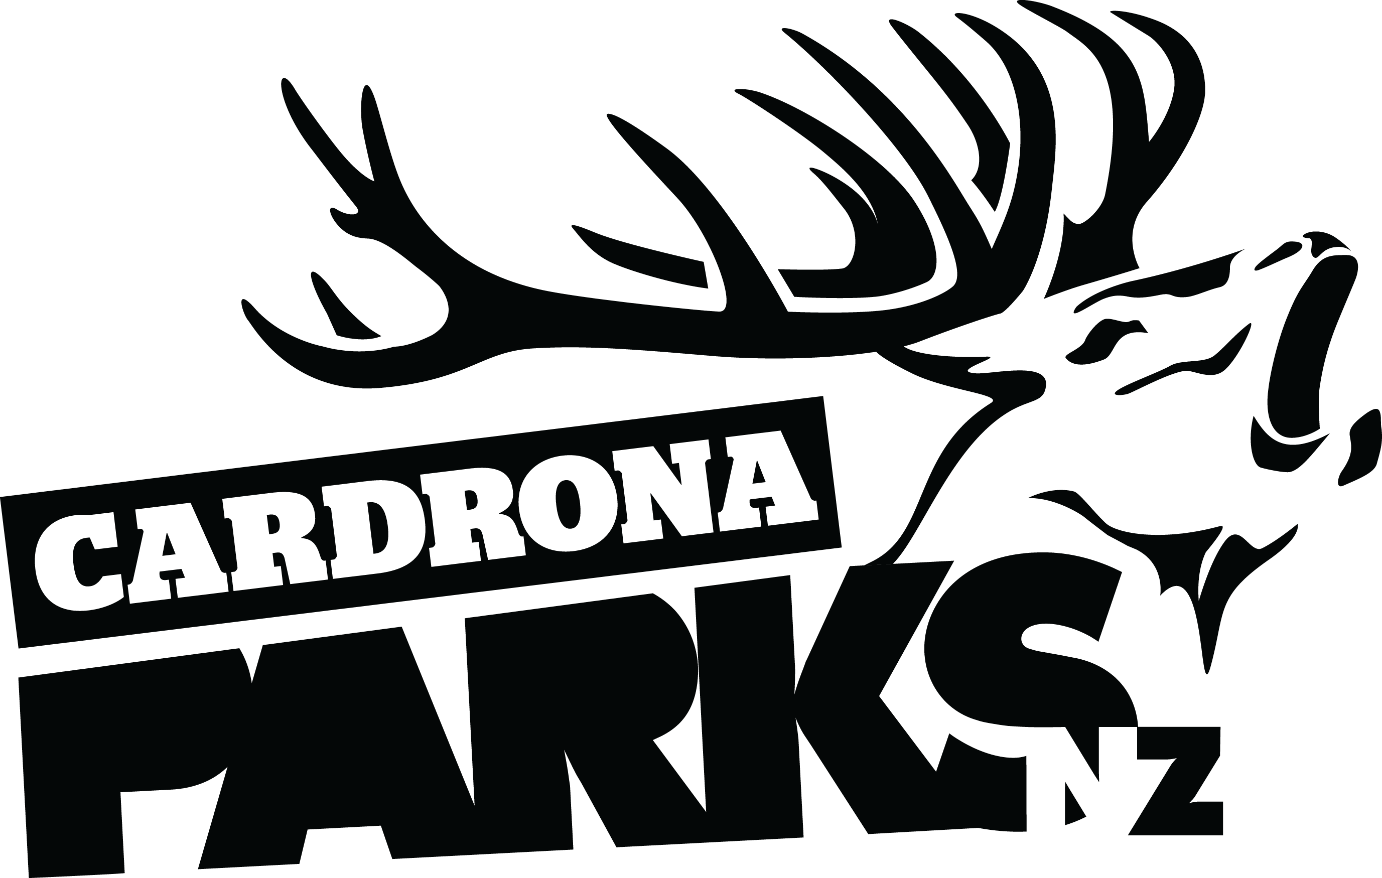
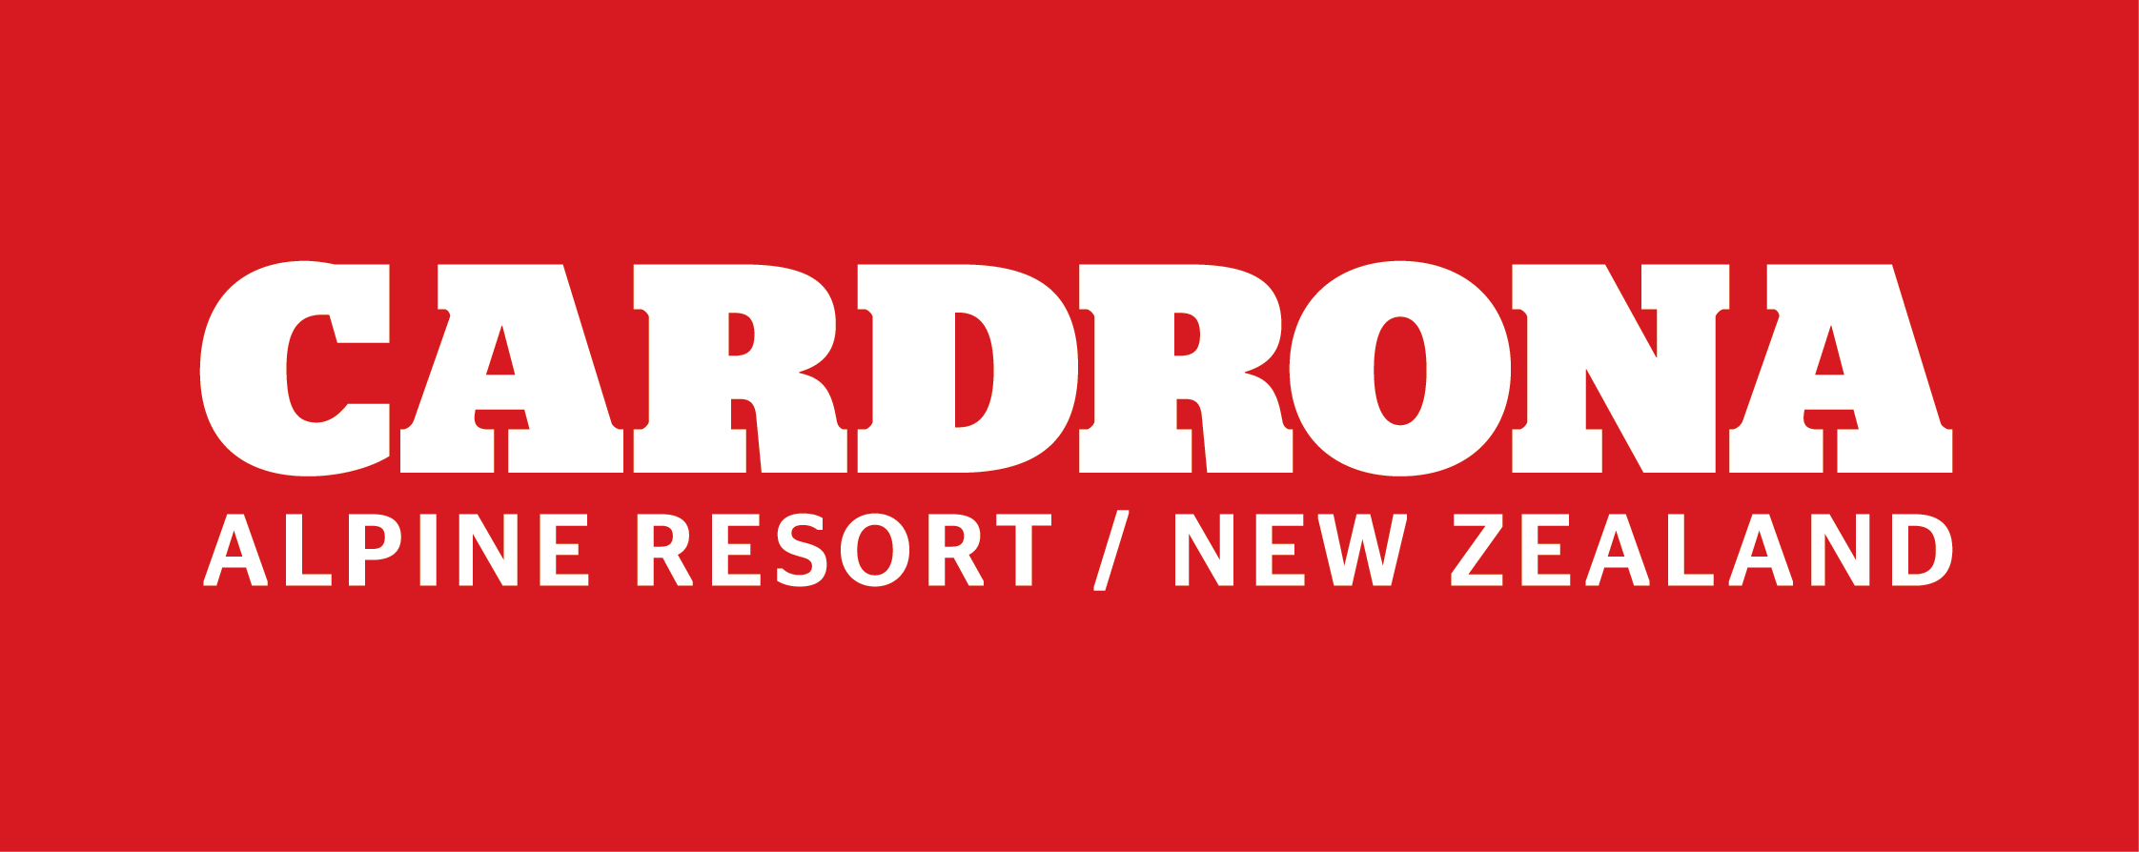

FOR IMMEDIATE RELEASE:
Cardrona Alpine Resort
Wanaka, NZ
October 15, 2017

RE: SIGNIFICANT GROWTH LEADS TO CONTINUED INVESTMENT IN CARDRONA ALPINE RESORT FACILITIES

The 2017 winter season has been another record-breaking year for Cardrona Alpine Resort, leading to continued investment in the resort in a multi-year development project.
Winter 2017 smashed the visitor records set in 2016, with the new McDougall’s Chondola and improved snowmaking facilities key factors behind the rise in numbers.
“With the new Chondola, it’s been so great to see the mountain lift facilities really cater for all our guests, and spread everyone out on busier days,” says Cardrona’s General Manager Bridget Legnavsky.
“Now that the lifts and snow can get more people out skiing and snowboarding on the mountain for longer, it’s time for our Base facilities to do the same.”
Cardrona’s Base and Mezz cafés are first on the list, with a refit of both eateries scheduled for the 2017/18 summer season. The refit will repurpose the existing spaces to accommodate more guests, more efficiently.
Other developments for Summer 2017/18 include a refit of Cardrona’s new Ski Concierge facility, a refit of Cardrona Corner in Wanaka including the introduction of bike and snow rental, refurbished staff areas, and a significant increase in snowmaking capabilities.
“We’ve identified a series of pinch points in our operations, so with this summer’s upgrades we’re continuing to minimise them so all our facilities accommodate our guests smoothly and efficiently,” says Legnavsky.
MORE
The resort’s master plan for the next two years after continues on this theme, while also looking to cater for a more advanced ski and snowboard market. The total investment over the next three years in the resort is forecast at over $20million.
“Don’t forget that since we replaced the McDougall’s Quad with the Chondola, we have a spare chair ready to be repurposed,” says Legnavsky.
Plans for new lift-accessed terrain with the old McDougall’s Quad will be confirmed and announced next winter.
Cardrona will remain open for high performance New Zealand and international athletes only for another week from today, with the resort’s annual Spring Camp training in Slopestyle, Halfpipe and Big Air.
The resort has also put 2018 season passes on sale in a “Price Freeze” at 2017’s rates, from today until the end of October. For more information, visit www.cardrona.com/freeze.
After the conclusion of Spring Camp, the resort has just five weeks to transform into a summer playground, with summer operations of mountain biking, mountain carting, hiking, sightseeing, stargazing and more beginning on December 2 and running all the way through till April 2, 2018.
For more information about summer at Cardrona, visit www.cardrona.com/summer.

ENDS

Media Enquiries:
Bridget Legnavsky
General Manager
Cardrona Alpine Resort
bridget@cardrona.com
Phone +64 27 550 0818

About Cardrona Alpine Resort
Founded in 1980, Cardrona Alpine Resort is New Zealand’s most popular ski area, where everyone’s a VIP – from beginners & families, to Olympic & X Games athletes. Cardrona’s 3 vast basins are home to NZ’s first cabin-style lift – the McDougall’s Express Chondola & the Southern Hemisphere’s most extensive terrain parks & pipes. Wide, open trails offer some of NZ’s best snow conditions, thanks to high altitude & an innovative snow management system. Take an easy drive from Queenstown or Wanaka & be welcomed with genuine Kiwi hospitality.

In the summer months Cardrona is open for mountain biking, carting, conferences & other alpine adventure activities. Cardrona is a wholly-owned subsidiary of Real Journeys Ltd.

