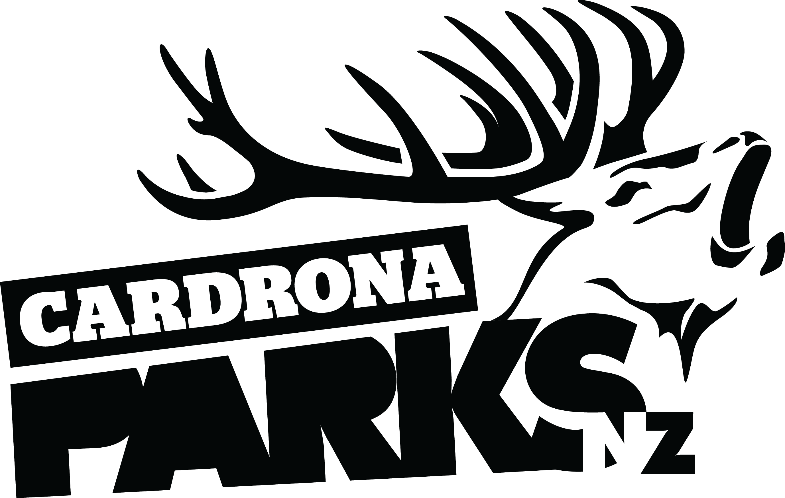

__________________________________________________________________________________
FOR IMMEDIATE RELEASE:
Cardrona Alpine Resort
Wanaka, NZ
August 13, 2016

RE: ATHLETES CALL THE “BEST JUMP IN THE WORLD” AT THE JOSSI WELLS INVITATIONAL
The Big Air jump for Monster Energy presents the Jossi Wells Invitational at Cardrona Alpine Resort has been dubbed the “best jump in the world” by the athletes attending the inaugural competition.
The finals of the Jossi Wells Invitational took place at Cardrona today, with a field of 20 skiers and snowboarders from around the world taking five jumps to show the large crowd of spectators their best tricks.
The signature event was a celebration of 2016 X Games gold medallist Jossi Wells at his home resort, Cardrona. The competition is set to become an annual event for the world’s best skiers and snowboarders.
“I’m very humbled and honoured to have the opportunity to throw this event for all the riders and the spectators,” says Jossi. “It all went off without a hitch – perfect day, perfect jump, and the riders all threw down.”
The men’s ski competition was taken out by Great Britain’s James “Woodsy” Woods, with New Zealand’s Jackson Wells in second, and Canada’s Noah Morrison in third place.
“The first ever Jossi Wells Invitational couldn’t have gone off in better conditions,” says Head Judge Tori Beattie. “The judges were seriously impressed by the local New Zealand talent – but the day belonged to James Woods.”
MORE
The men’s snowboard podium was dominated by local snowboarders with 17 year-old Tiarn Collins and Wanaka’s Stef Zeestraten in second and third place respectively. The top spot was claimed by heavy-hitting Australian youngster Matthew Cox.
The women’s side of the event was represented by 17 year-old Kiwi skier Margaux Hackett, and Canadian X Games gold medallist, snowboarder Spencer O’Brien.
“We were blown away by both Spencer [O’Brien] and Margaux [Hackett] spinning 720s on that jump. It’s so good to see girls throwing down, and we hope to see more of that in the future,” says Beattie.
The 85+ft Big Air was built by Cardrona’s Tom Campbell, who was also the first one to test the jump. Campbell received a resounding cheer from the crowd at prizegiving to recognise his work, building what James Woods described as “the best jump in the world – the best jump I’ve ever hit.”
Naming sponsors Monster Energy provided the US$20,000 cash purse for the men’s side of the event, with Dragon Alliance supporting the women’s competition. The athletes also attended a series of adventure activities in Queenstown and Wanaka at AJ Hackett Bungy & Nevis Swing, The Oxbow Adventure Company and Skydive Wanaka.
ENDS
__________________________________________________________________________________

Media Enquiries:
Bridget Legnavsky
General Manager
Cardrona Alpine Resort
bridget@cardrona.com
Phone 0275 500 818

About Cardrona Alpine Resort
Cardrona Alpine Resort is New Zealand’s most popular ski area, attracting all kinds of snow enthusiasts – from beginners & families, to Olympic & X Games athletes. Cardrona’s 3 vast basins are home to the Southern Hemisphere’s most extensive terrain parks & pipes, & NZ’s most qualified ski & snowboard school. Wide, open trails offer some of NZ’s best snow conditions, groomed to perfection by a modern & innovative snow management system. Take a short drive from Queenstown Airport over the spectacular Crown Range & be welcomed with genuine Kiwi hospitality to NZ’s ultimate winter playground. In the summer months Cardrona is open for mountain biking, conferences & other alpine adventure activities. Cardrona is a wholly owned subsidiary of Real Journeys Ltd.

