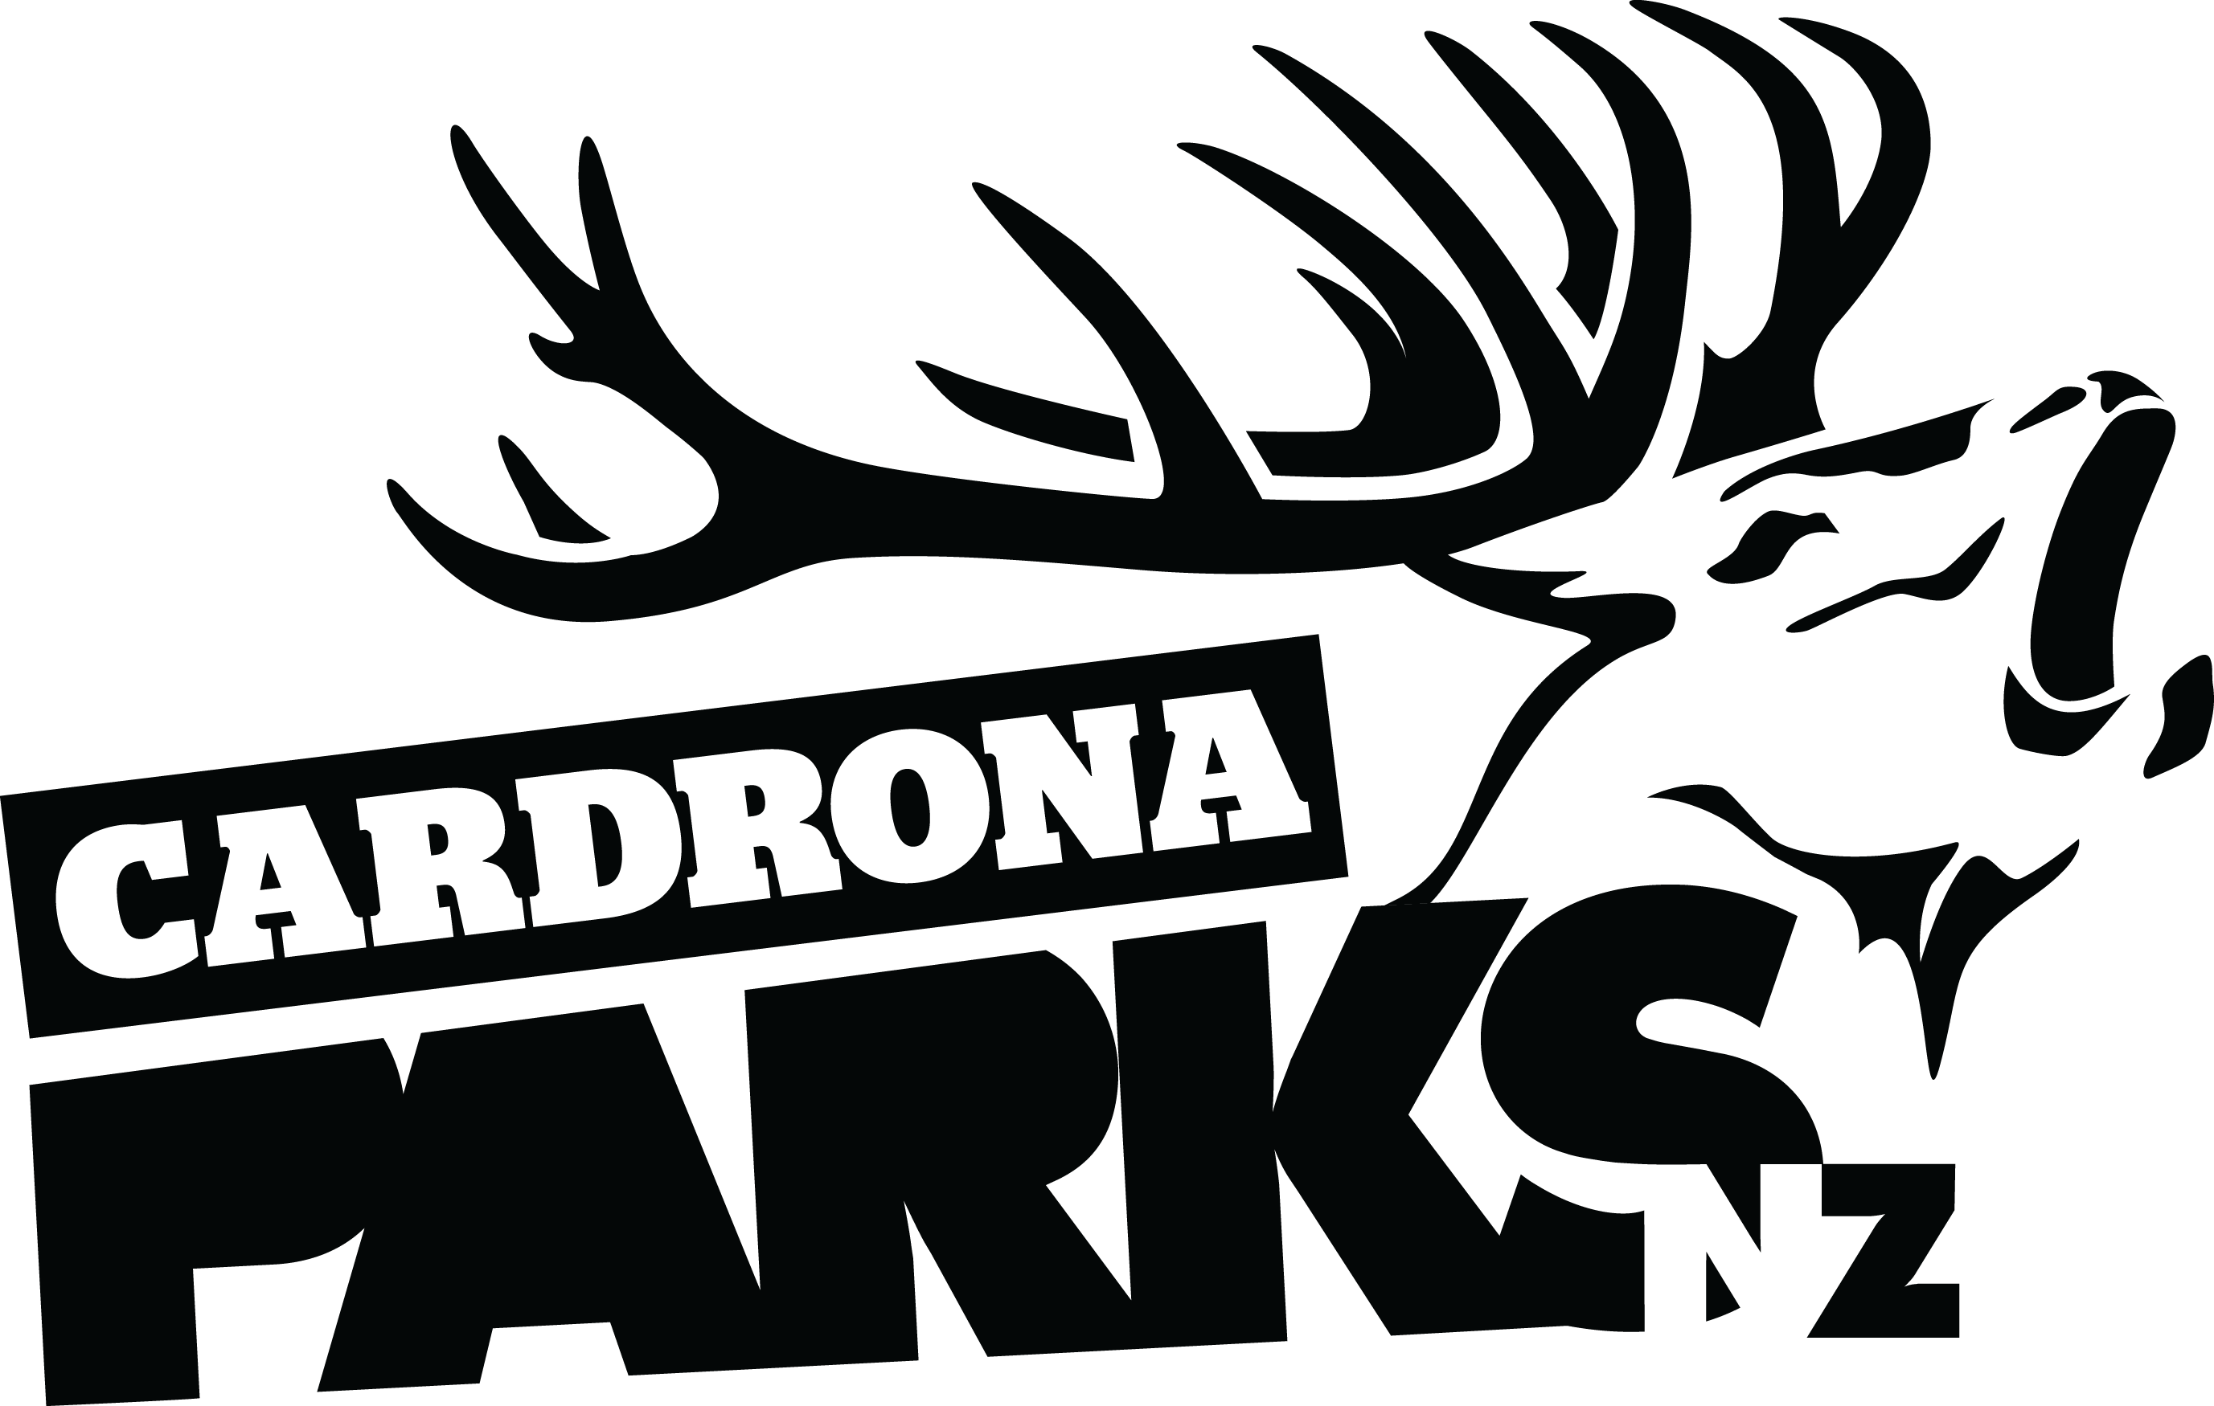
__________________________________________________________________________________
FOR IMMEDIATE RELEASE:
Cardrona Alpine Resort
Wanaka, NZ
August 11, 2016
RE: CARDRONA ANNOUNCES A GAME CHANGER FOR NEW ZEALAND SKI INDUSTRY
Cardrona Alpine Resort are changing the game for the New Zealand ski industry – installing a $10million combined lift of gondola cabins and chairs in time for the 2017 winter season. The new McDougall’s Express Chondola will be the first cabin-style lift on a ski area in New Zealand, replacing the existing McDougall’s Quad chairlift.
The current McDougall’s fixed-grip quad was installed in 1985, and has been a Cardrona stalwart ever since. The lift is the main access point to all the Cardrona beginner terrain, and runs slowly to load and unload first-time chairlift users safely.
The goal for a new McDougall’s lift is to make it an access lift for the whole mountain and all of Cardrona’s visitors, not just beginners. The new McDougall’s Express Chondola will be a high speed, detachable six-seater chair, with an eight-person gondola cabin between every four chairs. The lift will be a quick access point for the entire mountain, including Captain’s Basin.
“Cardrona approached me with a unique problem to solve – they needed a high speed lift for all mountain users, regardless of ability. The solution was a mix of gondola cabins and chairs that they can customize depending on weather and other requirements,” says Doppelmayr Austria’s Norbert Feuerstein.
The new McDougall’s Express Chondola will be 100m closer to Cardrona’s base area, making it faster and easier to get up the mountain. The Chondola will increase uphill capacity for McDougall’s by 150%, which will decrease wait times on all other mountain lifts.
MORE
The McDougall’s Express Chondola will provide a one of a kind beginner experience in New Zealand, with first time skiers & snowboarders able to walk on and off a gondola cabin, and ride to the top of the mountain on their first day. From the top of McDougall’s they can access the mellow Skyline trail with spectacular views of Queenstown and the Southern Alps, or New Zealand’s longest beginner trail, A Real Journey, at 3.2km long.
“This is going to be a game changer for all types of people wanting to experience the mountains in New Zealand. We are super stoked to be able to deliver this unique development for 2017,” says Cardrona’s General Manager Bridget Legnavsky.
“Cardrona has already made the move to take people to the top of the mountains across all seasons. This innovation will enhance the experience of all our visitors in both summer and winter. We are confident it will become one of the iconic summer rides in the region,” says Legnavsky.
The McDougall’s Express Chondola – Quick Facts
- 1:4 ratio of cabins to chairs
- 10 total cabins, 40 total chairs
- Cabins hold 8 people, chairs hold 6
- 3.5mins from base area to top of the mountain
- 7 towers (current McDougall’s Quad has 11 towers)
- Uphill capacity: 2550 people per hour (current McDougall’s Quad has 1000p/hr uplift)
- Gondola cabins and chairs will be stored in the lift’s top station, and can be reconfigured in layout depending on weather conditions
ENDS
__________________________________________________________________________________
Media Enquiries:
Bridget Legnavsky
General Manager
bridget@cardrona.com
Phone 0275 500 818
About Cardrona Alpine Resort
Cardrona Alpine Resort is New Zealand’s most popular ski area, attracting all kinds of snow enthusiasts – from beginners & families, to Olympic & X Games athletes. Cardrona’s 3 vast basins are home to the Southern Hemisphere’s most extensive terrain parks & pipes, & NZ’s most qualified ski & snowboard school. Wide, open trails offer some of NZ’s best snow conditions, groomed to perfection by a modern & innovative snow management system. Take a short drive from Queenstown Airport over the spectacular Crown Range & be welcomed with genuine Kiwi hospitality to NZ’s ultimate winter playground. In the summer months Cardrona is open for mountain biking, conferences & other alpine adventure activities. Cardrona is a wholly owned subsidiary of Real Journeys Ltd.

