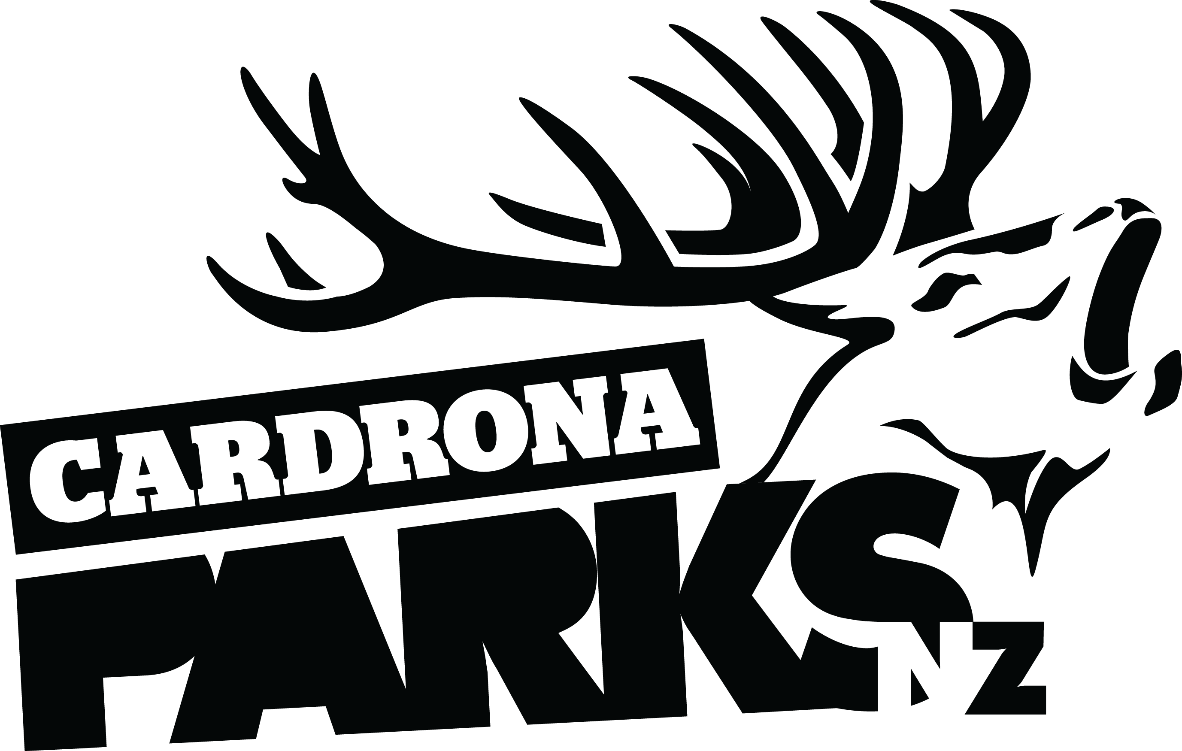
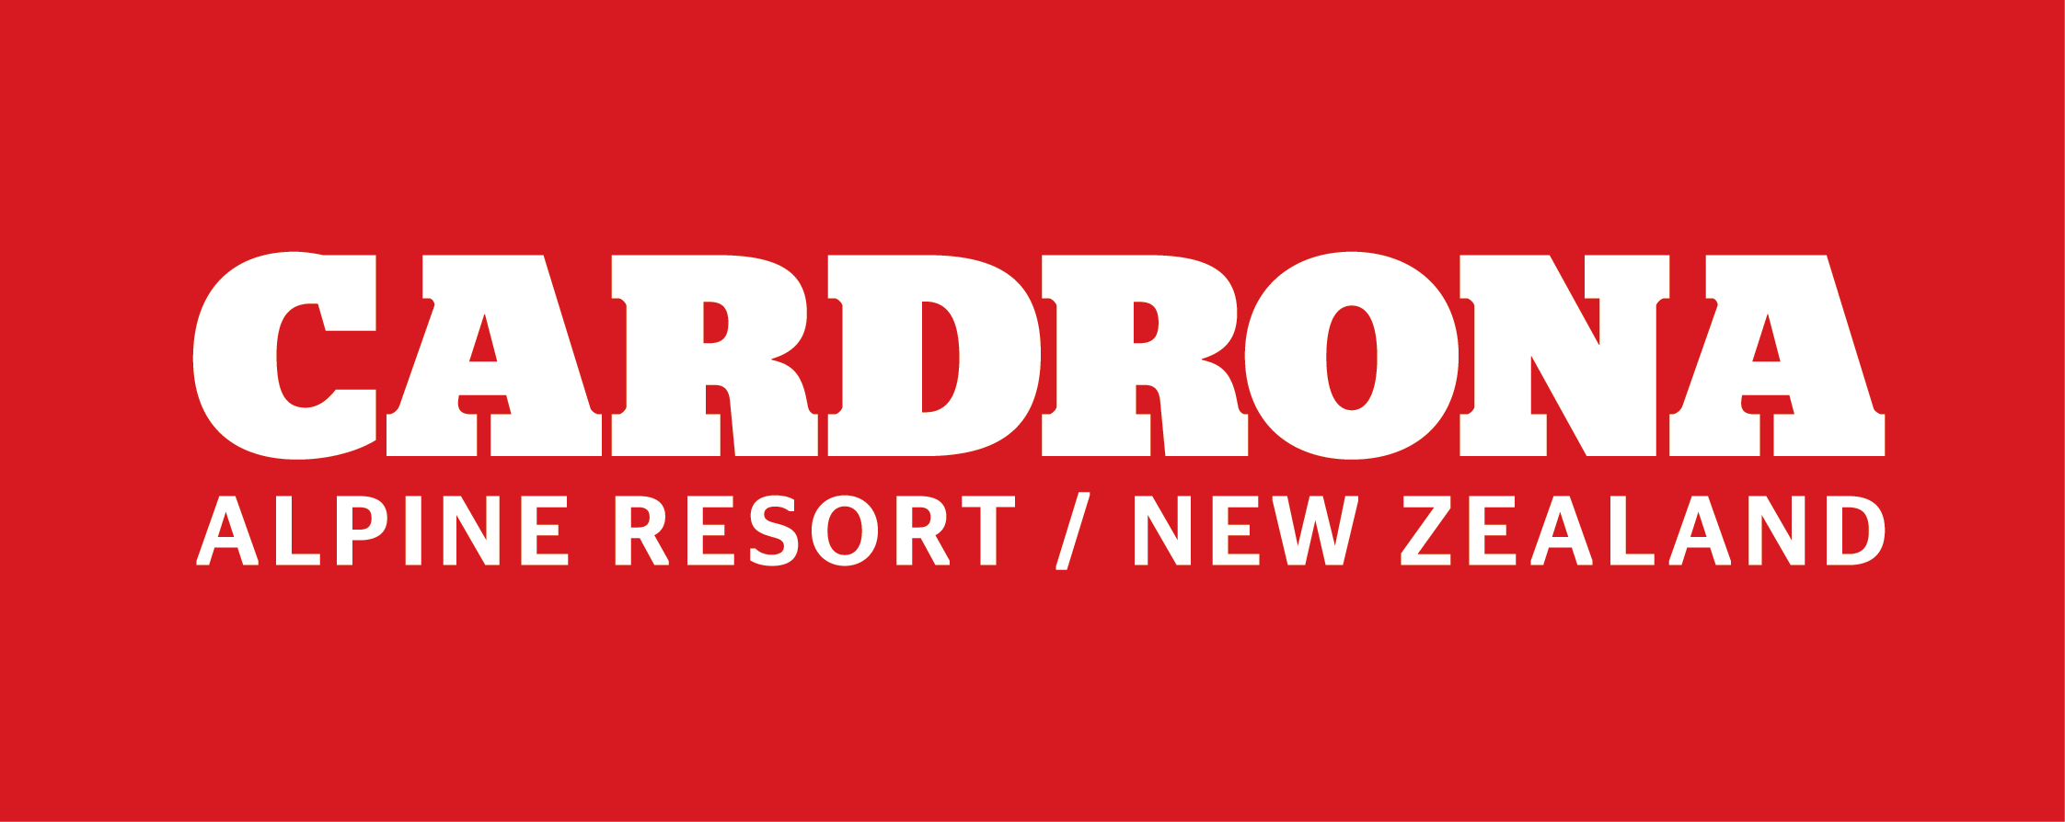

__________________________________________________________________________________
FOR IMMEDIATE RELEASE:
Cardrona Alpine Resort
Wanaka, NZ
December 20, 2016

RE: CARDRONA BUILDS ON MOUNTAIN BIKING SUCCESS WITH ADVENTURES FOR THE WHOLE FAMILY THIS SUMMER

Cardrona Alpine Resort is building on the success of their first full season of mountain biking in 2015/16, with gravity-fuelled adventures for the whole family this summer, including tubing for the first time. The 2016/17 summer season of operations at the resort opens on December 27.
Cardrona’s network of lift-accessed mountain bike trails will be home to the New Zealand Mountain Bike Nationals for the third time this summer, joining the Cardrona Mega Avalanche as a summer staple event at the resort. This season, mountain bikers will also be able to ride to the iconic Cardrona Hotel daily on Cardrona’s Peak to Pub trail, which covers 1270m of vertical over 10km.
Beginner mountain bikers will make use of the new Learners’ Zone Flow Track and skills area, accessed by Cardrona’s covered Learner Conveyor. The track has been specially designed to prepare first time downhill bikers for the rest of the trails across the mountain. Once again, Cardrona is offering private mountain bike lessons for riders of all ages and abilities.
Cardrona is offering summer tubing for the first time this season, next to the Learners’ Zone Flow Track. Other activities for non-bikers this summer include New Zealand’s first mountain carts, hiking and walking trails, and Cardrona’s Alpine by Night experiences.
MORE
Cardrona’s new events division, GoldX Events, will also be hosting a range of lifestyle events this summer. Yoga Retreats will see enthusiasts taking residence on the mountain for a weekend, while the Kids and Kites Family Day will welcome the whole family up to Cardrona for a day of kite making workshops and alpine flying.
“We’re so excited for another great summer up at Cardrona,” says Cardrona’s General Manager, Bridget Legnavsky. “With more activities for everyone this year, summer operations are growing and growing – we can’t wait for everyone to come up and check it out!”
Visitors to Cardrona this summer will be able to see the construction of New Zealand’s first cabin-style lift on an alpine resort – the McDougall’s Express Chondola. The new lift will be in place in time for the 2017 winter season.
For more information about summer at Cardrona, visit www.cardrona.com.
ENDS
__________________________________________________________________________________

Media Enquiries:
Bridget Legnavsky
General Manager
Cardrona Alpine Resort
bridget@cardrona.com
Phone 0275 500 818

About Cardrona Alpine Resort
Cardrona Alpine Resort is New Zealand’s most popular ski area, attracting all kinds of snow enthusiasts – from beginners & families, to Olympic & X Games athletes. Cardrona’s 3 vast basins are home to the Southern Hemisphere’s most extensive terrain parks & pipes, & NZ’s most qualified ski & snowboard school. Wide, open trails offer some of NZ’s best snow conditions, groomed to perfection by a modern & innovative snow management system. Take a short drive from Queenstown Airport over the spectacular Crown Range & be welcomed with genuine Kiwi hospitality to NZ’s ultimate winter playground. In the summer months Cardrona is open for mountain biking, conferences & other alpine adventure activities. Cardrona is a wholly owned subsidiary of Real Journeys Ltd.

