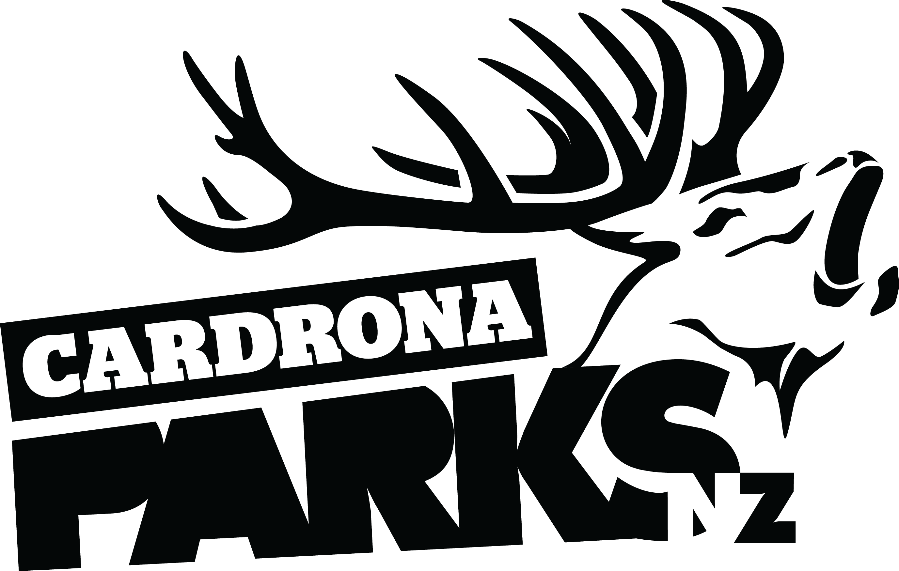

______________________________________________________________________________
FOR IMMEDIATE RELEASE:
Cardrona Alpine Resort
Wanaka, NZ
October 9, 2016
RE: CONTINUED INVESTMENT LEADS TO MOST SUCCESSFUL SEASON ON RECORD FOR CARDRONA ALPINE RESORT
Continued investment in facilities and infrastructure has led to the most successful winter season on record for Cardrona Alpine Resort this year. Cardrona’s previous skier day record has been smashed by over 30,000 visits this year – a sign of growth in both the snow sports and local tourism industries.
Investing in key areas such as carparking and the Valley View base area, along with a focus on minimising pinch points, has created a more even spread of capacity. Continual investment in terrain management including the SnowSat system, snowmaking capacity and grooming fleet has created a more stable, season-long product.
The entire resort was open top to bottom on Opening Day June 11, including Valley View Quad for the first time in the lift’s history. Early snowfall, increased snowmaking capacity and tactical terrain management saw the resort fully operational from day one.
“It’s been a fantastic season at Cardrona. The snow came just when we needed it and we opened the whole mountain on schedule,” says Cardrona’s General Manager Bridget Legnavsky.
Cardrona’s Closing Day on Sunday saw a range of events for the whole family to celebrate the change in season together. Throughout the day there was live music in the Courtyard, the Fashion in the Field catwalk, as well as many keen skiers & snowboarders trying to make it across the 12m long pond skim at the base of McDougall’s Quad.
MORE

The final event of Closing Day was a celebration of the end of Winter 2016, and the start of the summer operational season. More than 50 competitors took part in the Fun Never Stops race from the slopes all the way down to the Cardrona Village Domain.
The race started with an eating and puzzle challenge at the Base Area before heading up McDougall’s Quad. Competitors then skied or snowboarded across the pond skim, under a commando net and through a “snakes and ladders” course before transitioning to their bikes and riding all the way down to the Cardrona Valley.
The Fun Never Stops was the finale in a long season of event highlights at Cardrona. August’s Jossi Wells Invitational Big Air was a huge hit with both athletes and spectators, with competitors lauding the Cardrona Big Air “the best jump in the world”. Cardrona’s new year-round events division, GoldX Events, is part of the resort’s strategy to grow in traditionally quieter times.
“It’s an exciting time for Cardrona – this season’s strong visitor numbers, fantastic events like the Jossi Wells Invitational, and our athletes’ amazing performances have all helped raise the profile of the resort and the snow sports industry as a whole,” says Legnavsky.
With the resort closing to the public today, the doors are now open to the world’s best skiers and snowboarders for Cardrona’s annual Spring Camp. For two weeks, athletes from across the world will join New Zealand’s best in a training camp specifically designed for progression, including Big Air, Slopestyle, & Halfpipe programmes.
The 31 year-old McDougall’s Quad had its final swansong, calling its very last chair to the public today. Work will commence shortly on Cardrona’s New Zealand first McDougall’s Express Chondola, which will be installed in time for Winter 2017, all as part of Cardrona’s bigger development plan.
“We’re all going on a journey to make Cardrona as good as we can,” says Legnavsky. “You know it’s been a great season when your heart sinks as you see the trees turn green and the snow start to melt!”
Cardrona’s 2017 season passes are on sale from now until October 31 in a price freeze on the 2016 rates. For more information, visit www.cardrona.com/seasonpasses.
ENDS
__________________________________________________________________________________
Media Enquiries:
Bridget Legnavsky
General Manager
Cardrona Alpine Resort
bridget@cardrona.com
Phone 0275 500 818
About Cardrona Alpine Resort
Cardrona Alpine Resort is New Zealand’s most popular ski area, attracting all kinds of snow enthusiasts – from beginners & families, to Olympic & X Games athletes. Cardrona’s 3 vast basins are home to the Southern Hemisphere’s most extensive terrain parks & pipes, & NZ’s most qualified ski & snowboard school. Wide, open trails offer some of NZ’s best snow conditions, groomed to perfection by a modern & innovative snow management system. Take a short drive from Queenstown Airport over the spectacular Crown Range & be welcomed with genuine Kiwi hospitality to NZ’s ultimate winter playground. In the summer months Cardrona is open for mountain biking, conferences & other alpine adventure activities. Cardrona is a wholly owned subsidiary of Real Journeys Ltd.

