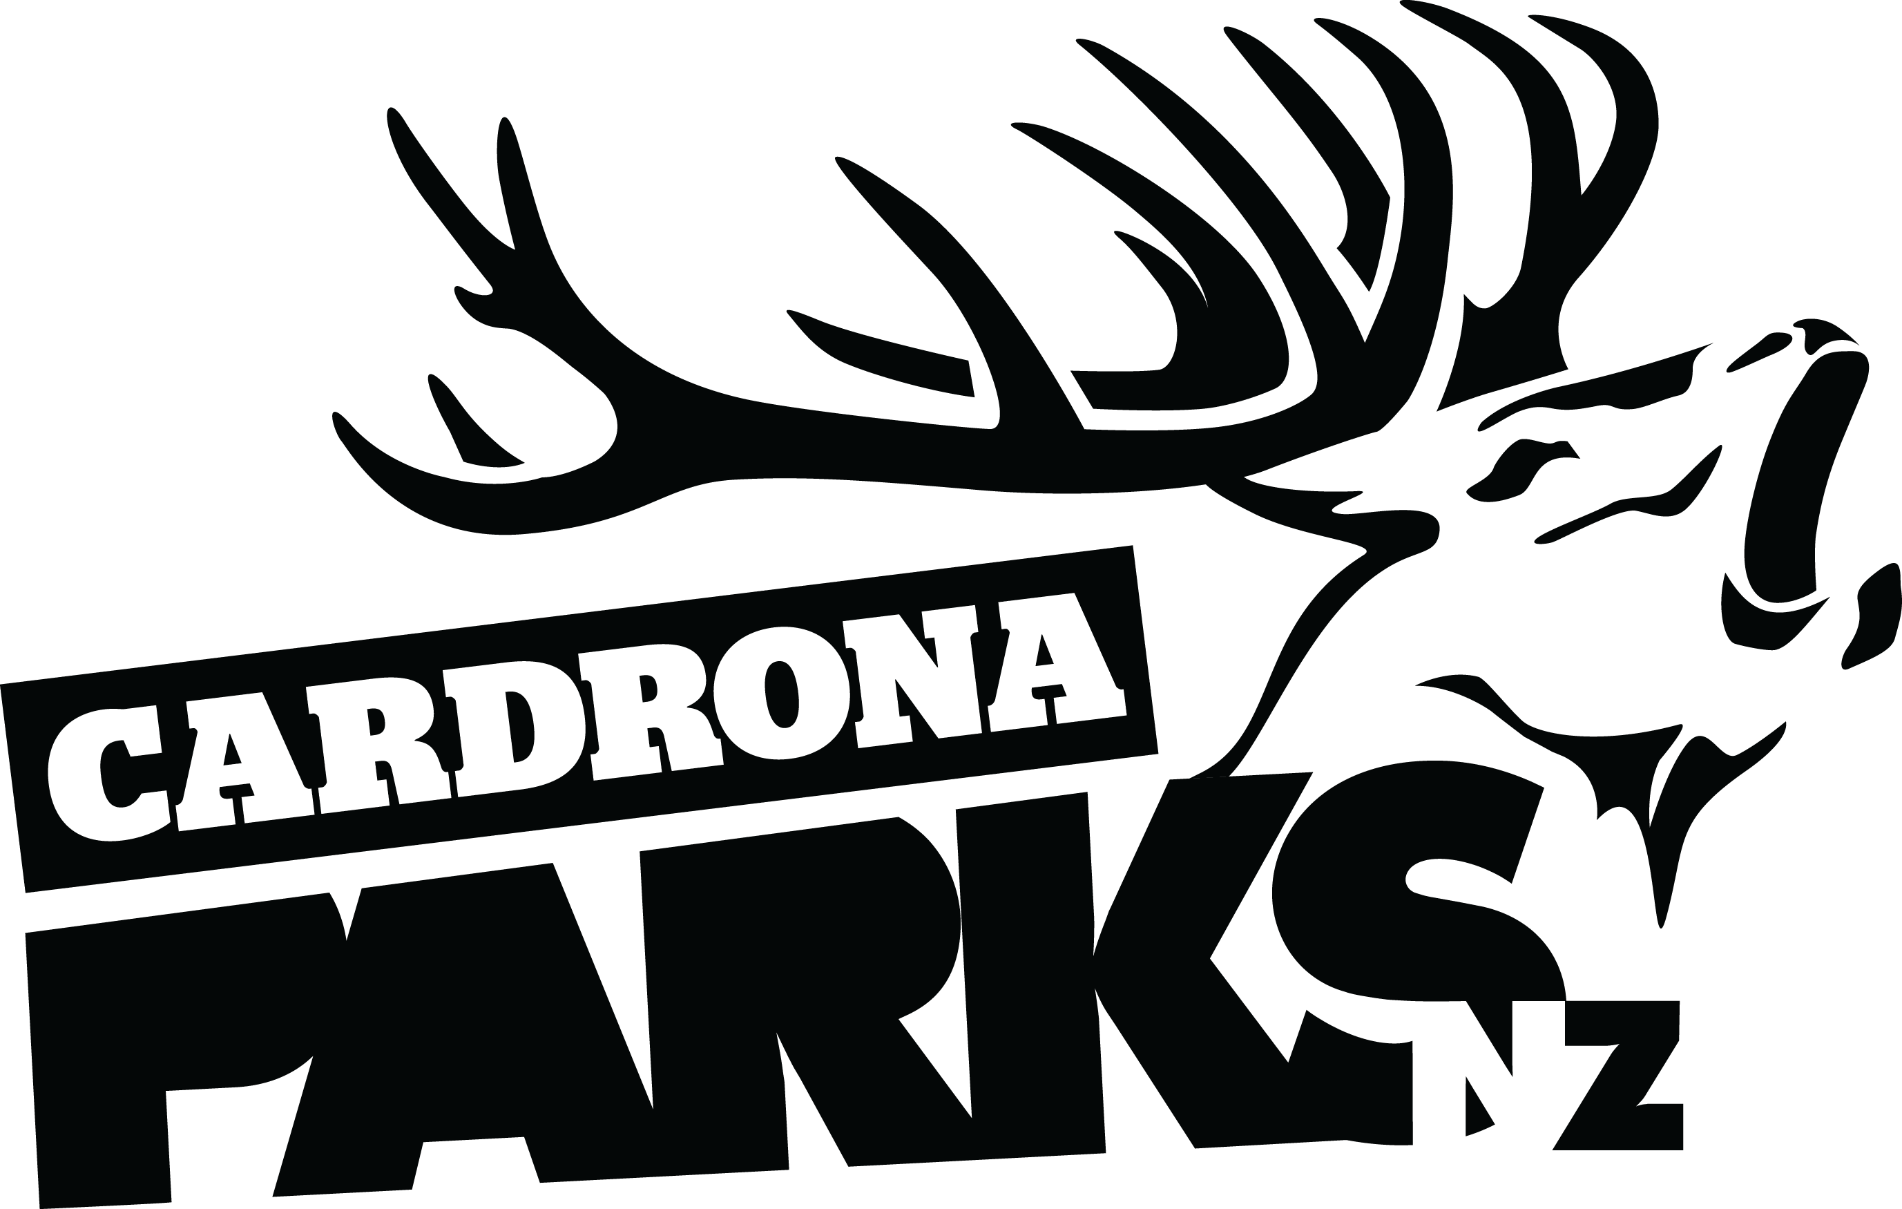

__________________________________________________________________________________
FOR IMMEDIATE RELEASE:
Cardrona Alpine Resort
Wanaka, NZ
July 22, 2016

RE: MONSTER ENERGY PRESENTS THE JOSSI WELLS INVITATIONAL, CARDRONA NZ
Winter X Games gold medallist Jossi Wells is holding an invitational Big Air event for the world’s best skiers & snowboarders at Cardrona Alpine Resort this August. Kiwi skiers and snowboarders will go head to head against a stacked field of international heavy hitters, with finals scheduled for Saturday, August 13th.
The event will run over two days, with qualifiers and finals for both men’s and women’s ski and snowboard events. It will take place on Cardrona’s huge 75+ft Big Air jump, which will be specially built for the competition.
The event celebrates a relationship between Jossi Wells and Cardrona that spans more than 20 years, as well as Jossi’s recent success in winning Ski Slopestyle gold at the most recent Winter X Games at Aspen, Colorado.
“I'm really honoured to be given the opportunity to collaborate on an event with Cardrona. Cardrona is my home mountain – I learnt how to ski here and have spent every winter riding at Cardrona since I could walk,” says Jossi.
“To be able to give back to the industry with the resort that has supported me for so long is really amazing. It's really cool to be able to throw an event at home for my international & local peers."
MORE
The invited athletes will also take part in adventure and adrenaline activities based in the Southern Lakes region in the days before the competition, to welcome them to New Zealand in the most exciting way possible.
On event days there will be free spectating zones on the mountain at the base of McDougall’s Quad by the fence, and the Noodle Bar. There will be a snow bar and Monster Energy sampling area at the McDougall’s viewing area. Skiing and snowboarding guests will find amazing view points of the Big Air from the Skyline Ridge above the jump, accessed by McDougall’s and Whitestar chairlifts.
The athletes are competing for a share of a US$20,000 cash purse, with the men’s ski and snowboard event prizes contributed by naming sponsor Monster Energy. The women’s event prizes are sponsored by Dragon Alliance.
The snowboard competition is particularly significant in the lead up to the 2018 Pyeongchang Winter Olympics, where Snowboard Big Air will make its debut as an Olympic event. The ski side of the competition has been sanctioned as a silver event on the AFP world tour.
The Jossi Wells Invitational for 2016 is the inaugural event of what is hoped to become an annual, internationally significant event on the professional skiing and snowboarding calendars.
For more announcements about confirmed athletes and event streaming, keep an eye on Cardrona’s Facebook and Twitter accounts.
ENDS
__________________________________________________________________________________

Media Enquiries:
Bridget Legnavsky
General Manager
Cardrona Alpine Resort
bridget@cardrona.com
Phone 0275 500 818
About Cardrona Alpine Resort
Cardrona Alpine Resort is New Zealand’s most popular ski area, attracting all kinds of snow enthusiasts – from beginners & families, to Olympic & X Games athletes. Cardrona’s 3 vast basins are home to the Southern Hemisphere’s most extensive terrain parks & pipes, & NZ’s most qualified ski & snowboard school. Wide, open trails offer some of NZ’s best snow conditions, groomed to perfection by a modern & innovative snow management system. Take a short drive from Queenstown Airport over the spectacular Crown Range & be welcomed with genuine Kiwi hospitality to NZ’s ultimate winter playground. In the summer months Cardrona is open for mountain biking, conferences & other alpine adventure activities. Cardrona is a wholly owned subsidiary of Real Journeys Ltd.

