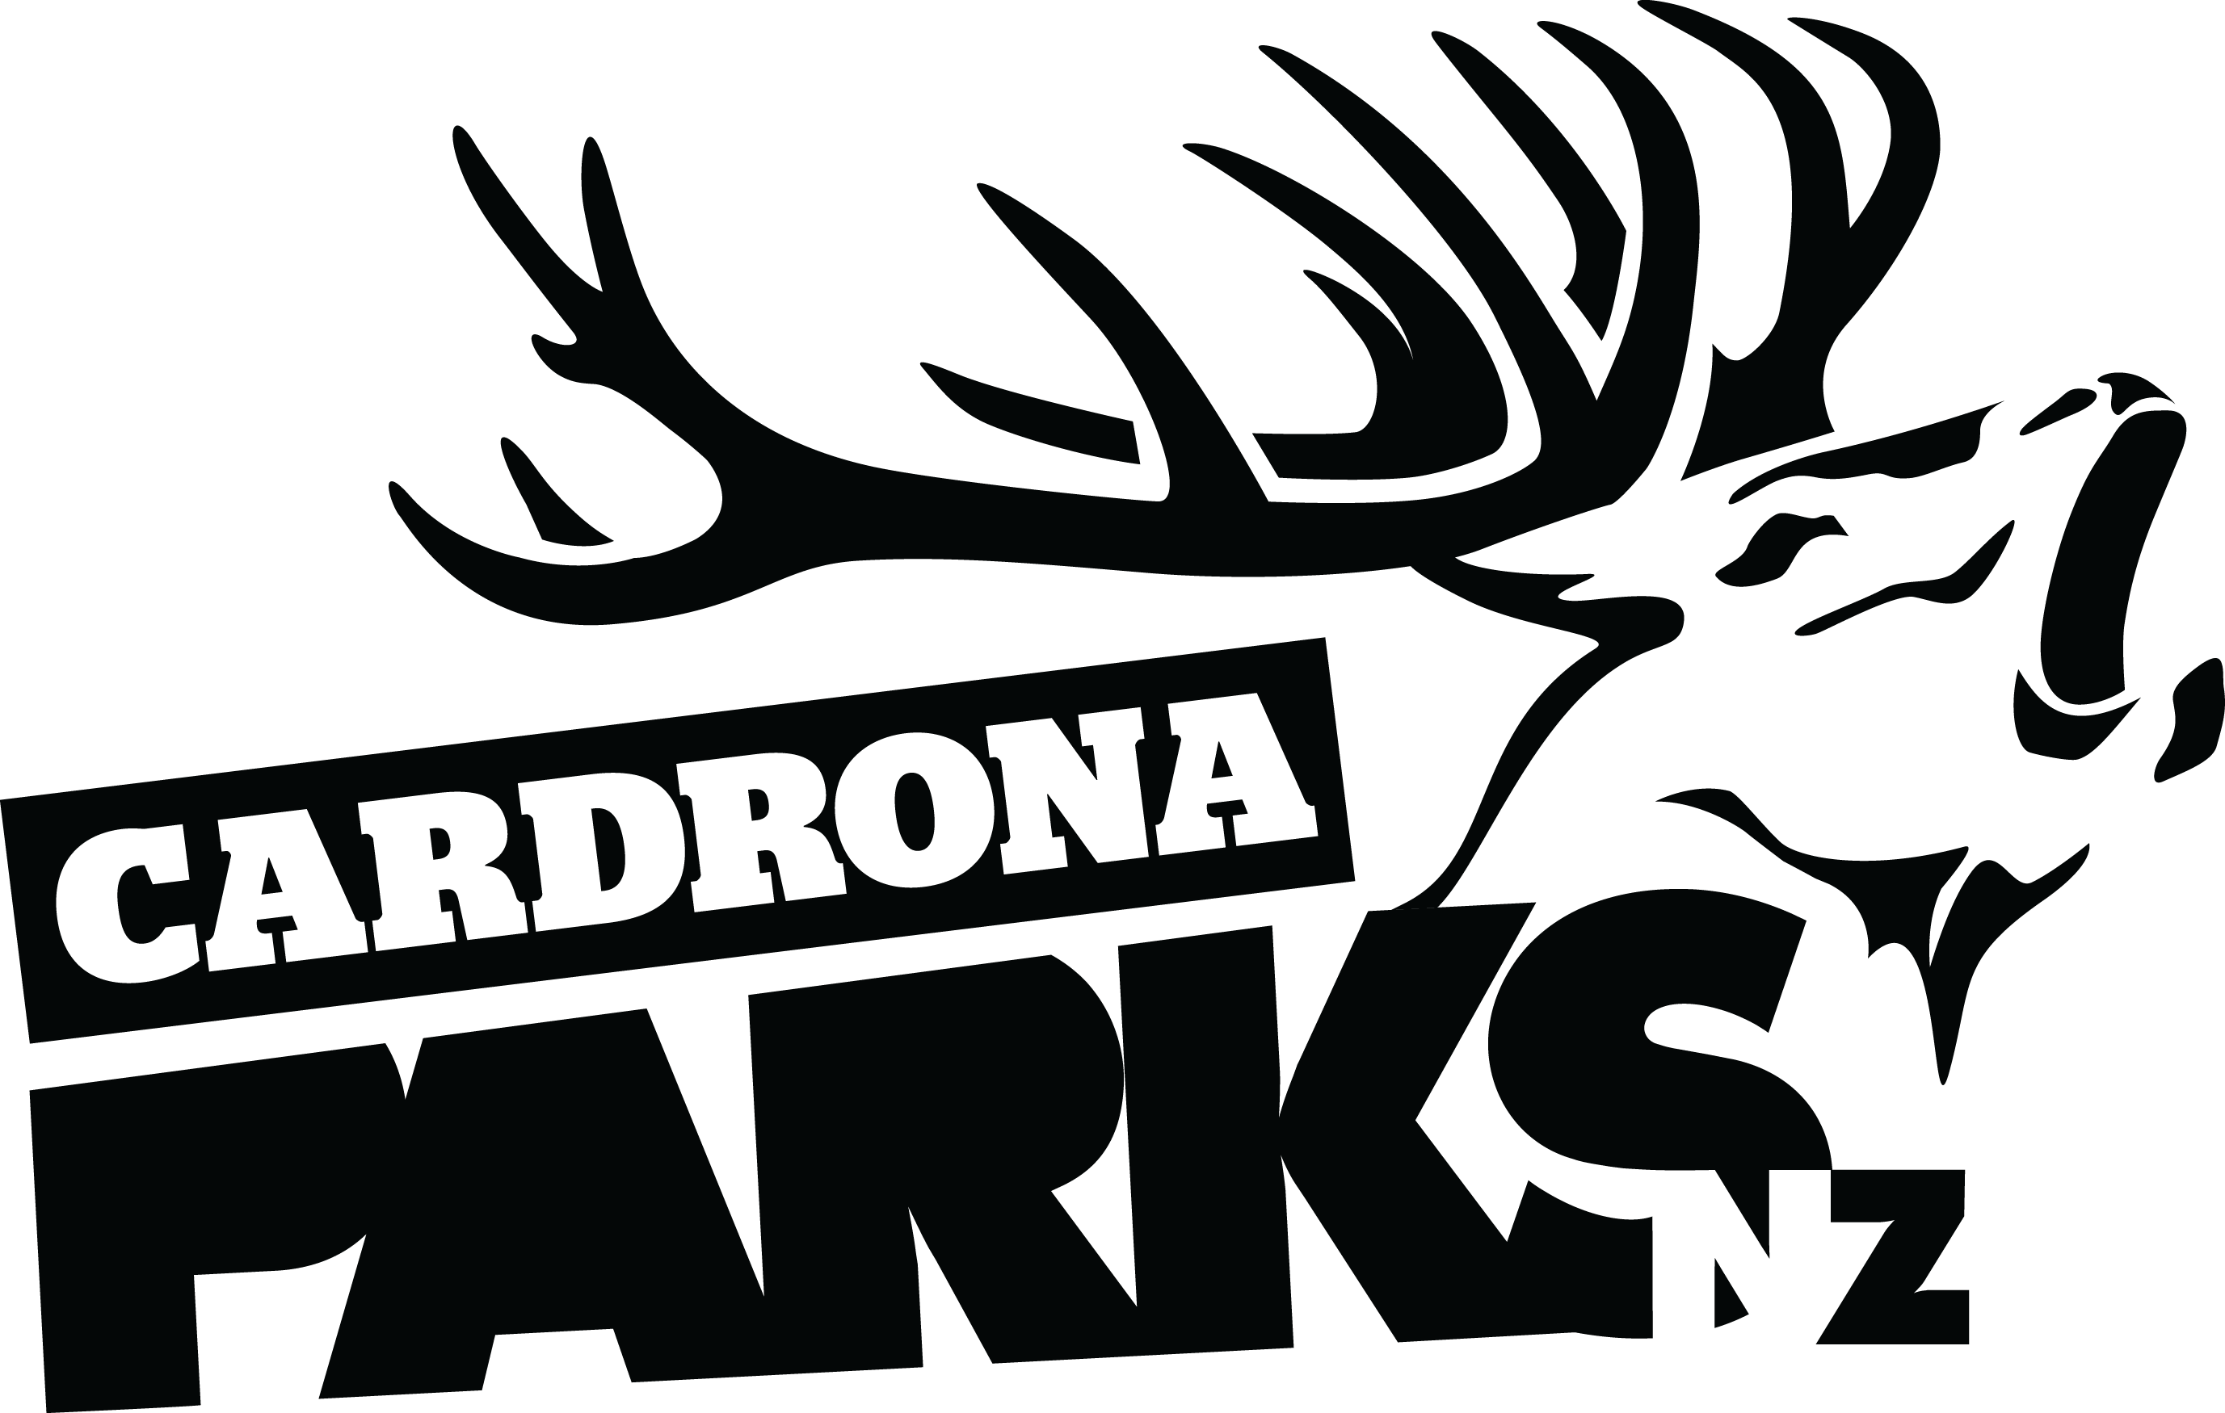

__________________________________________________________________________________
FOR IMMEDIATE RELEASE:
Cardrona Alpine Resort
Wanaka, NZ
October 25, 2016

RE: PROGRESSION FOR YOUNG AND VETERAN ATHLETES ALIKE AT CARDRONA’S ANNUAL SPRING CAMP
This October’s annual Cardrona Spring Camp has been yet another major progression session for young and veteran athletes alike. 150 elite, international athletes and their coaches trained up at Cardrona Alpine Resort for the past fortnight in a private camp for Slopestyle, Halfpipe and Big Air skiers and snowboarders.
12 year-old American freeskier Troy Podmilsak now holds the world record as the youngest skier to land a triple cork 1440 – a record previously claimed by 14 year-old Kiwi, Nico Porteous, only months ago, on Cardrona’s 85ft Big Air jump. Not to be outdone by young buck Podmilsak, Kiwi veteran Jossi Wells landed a new triple cork of his own just days later – his first triple cork 1620.
Cardrona’s Big Air jump has been lauded all season as “the best jump in the world” by both local and international athletes. Spring Camp was a continuation of the progression facilitated by Tom Campbell’s jump in Winter 2016, including the first ever quad cork on skis a month ago by youngest Wells brother, Jackson.
The 22ft Superpipe has also attracted some of the world’s best skiers and snowboarders, with the USA’s Shaun White, Danny Davis, Chloe Kim and Kelly Clark all training for the Pyeongchang Winter Olympic Snowboard Halfpipe event at Spring Camp.

MORE
“It’s been great to be riding all day in October, and having a chairlift running has been key – some days we’ve been out until 4pm, says X Games gold medallist Danny Davis.
“The park staff have been great working with a pipe in warm weather. We got really lucky with fresh snow too – we’ve had a blast!”
The inclusion of Snowboard Big Air at the next Olympics has seen younger international snowboarders progressing their jump tricks. Australia’s Matty Cox landed his first triple cork last week, following on from his first place success at the Jossi Wells Invitational in August.
As Cardrona is the home of the New Zealand Park and Pipe team, the resort has also played host to the Snow Sports NZ development camp, which has seen New Zealand’s best young athletes training alongside international professional skiers and snowboarders.
“The 2016 Cardrona Spring Camp has yet again lived up to expectations for the NZ Park and Pipe team,” says Snow Sports NZ Performance Director Ashley Light.
“The facilities are truly world class and have allowed not only New Zealand athletes, but athletes from all over the world to train and prepare for the upcoming Olympic qualification period.”
After Spring Camp’s wrap on Sunday, work will now begin on Cardrona’s new McDougall’s Express Chondola, which will be installed in time for next winter. Cardrona’s summer season of mountain biking, mountain carting, walking and other alpine activities opens on December 27.
ENDS
__________________________________________________________________________________
Media Enquiries:
Bridget Legnavsky
General Manager
Cardrona Alpine Resort
bridget@cardrona.com
Phone 0275 500 818
About Cardrona Alpine Resort
Cardrona Alpine Resort is New Zealand’s most popular ski area, attracting all kinds of snow enthusiasts – from beginners & families, to Olympic & X Games athletes. Cardrona’s 3 vast basins are home to the Southern Hemisphere’s most extensive terrain parks & pipes, & NZ’s most qualified ski & snowboard school. Wide, open trails offer some of NZ’s best snow conditions, groomed to perfection by a modern & innovative snow management system. Take a short drive from Queenstown Airport over the spectacular Crown Range & be welcomed with genuine Kiwi hospitality to NZ’s ultimate winter playground. In the summer months Cardrona is open for mountain biking, conferences & other alpine adventure activities. Cardrona is a wholly owned subsidiary of Real Journeys Ltd.

