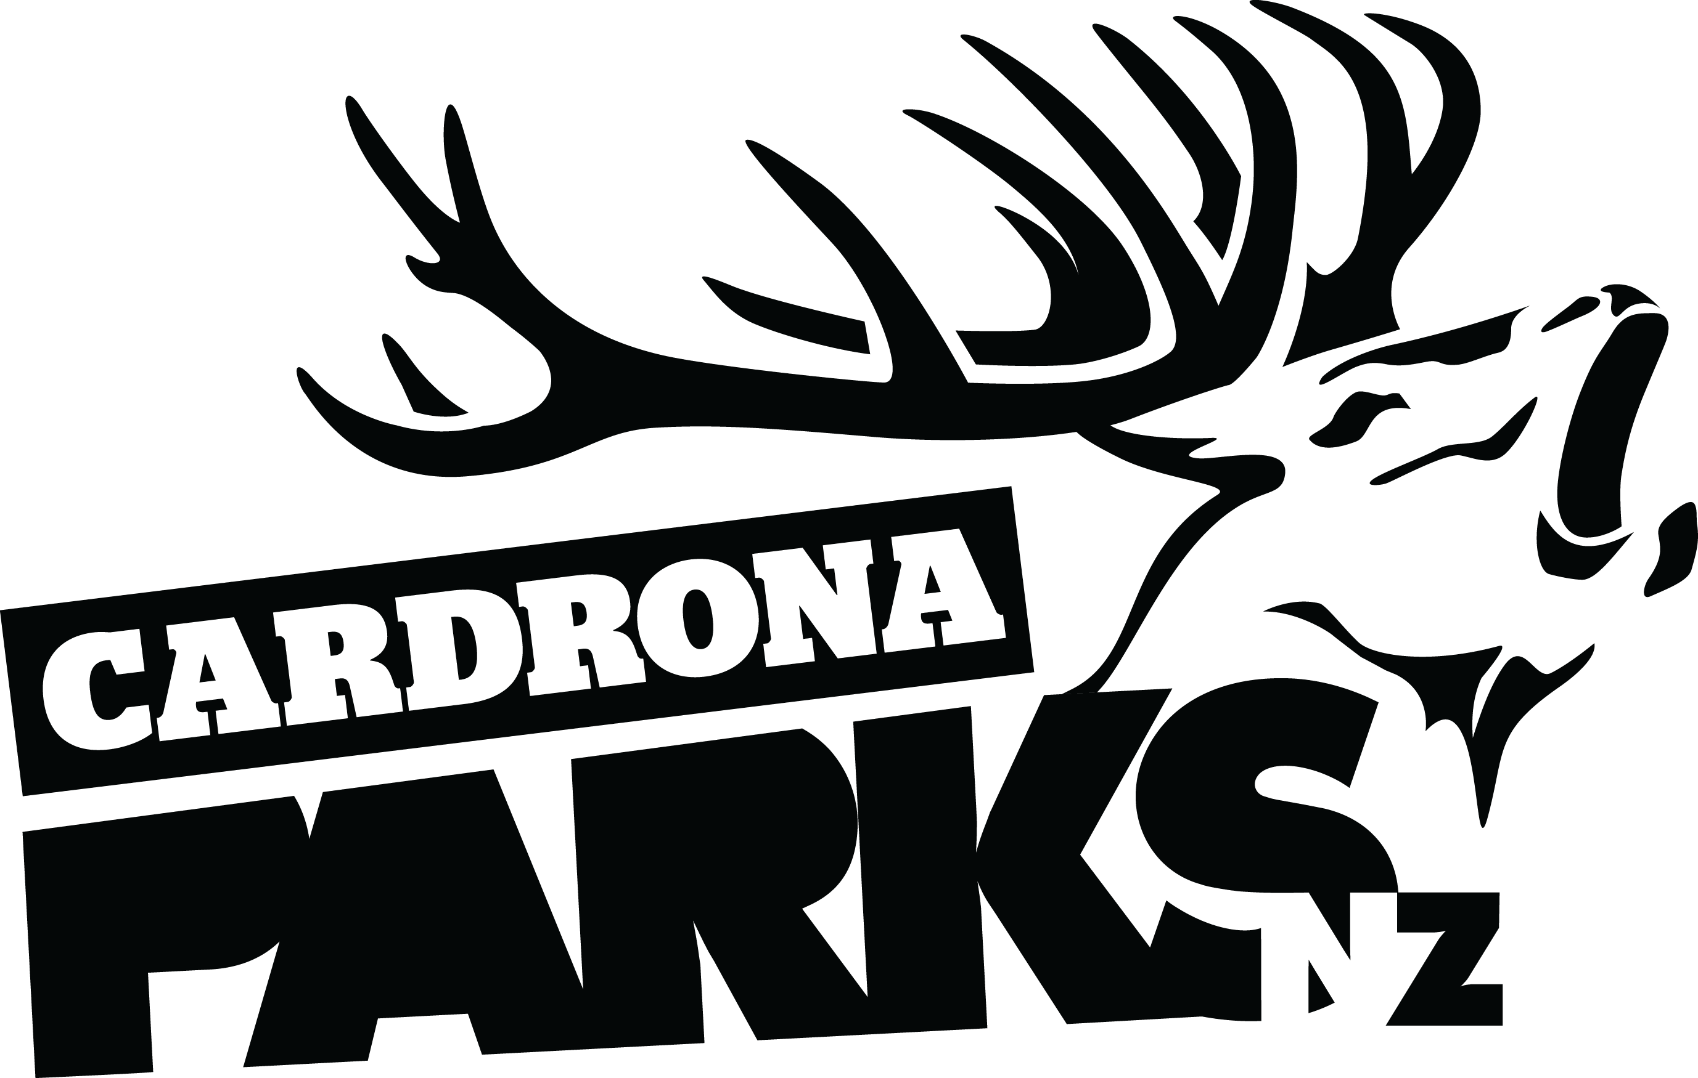

__________________________________________________________________________________
FOR IMMEDIATE RELEASE:
Cardrona Alpine Resort
Wanaka, NZ
July 26, 2016

RE: RECORD BREAKING START TO 2016 WINTER AT CARDRONA
The start of the 2016 winter has been a record-breaker for Cardrona Alpine Resort, with a 20% growth on previous winters. The growth has largely come from an influx of first time skiers and snowboarders, with the resort gearing up for a further increase in visitors over the next few years.
The resort has seen a greater number of first time skiers and snowboarders than any other segment this season. The new see-through tunnel over the Learner Conveyor has provided thousands of first timers a unique experience as they have learnt to ski and snowboard.
“It’s exciting to see so many people coming to learn to ski and snowboard at Cardrona,” says Cardrona’s General Manager Bridget Legnavsky. “It’s such a positive sign for the future of the industry – snow sports are alive and well.”
Pre-season developments at Cardrona have paid dividends with the mountain able to handle the higher numbers of skiers, snowboarders and sightseers. Cardrona are focusing on the mountain’s “pinch points” when making development decisions – something that is paying off during busier periods.
Developments for the 2016 winter included more parking options further down the mountain road to increase capacity. A new carpark was installed at the 1km mark on the road, with a return shuttle service offered for guests who park there.
MORE
Valley View developments, including a new carpark and “Little Meg” café, have seen more guests using the lower mountain lift to access the mountain. Increased snowmaking capability all the way to the base of Valley View Quad (at 1260m) has seen skiers and snowboarders consistently using the lift throughout the day.
Cardrona’s development plan is continuing over the next few years to address ways of handling increased capacity as numbers of skiers and snowboarders visiting the region continue to grow.
ENDS
__________________________________________________________________________________

Media Enquiries:
Bridget Legnavsky
General Manager
Cardrona Alpine Resort
bridget@cardrona.com
Phone 0275 500 818

About Cardrona Alpine Resort
Cardrona Alpine Resort is New Zealand’s most popular ski area, attracting all kinds of snow enthusiasts – from beginners & families, to Olympic & X Games athletes. Cardrona’s 3 vast basins are home to the Southern Hemisphere’s most extensive terrain parks & pipes, & NZ’s most qualified ski & snowboard school. Wide, open trails offer some of NZ’s best snow conditions, groomed to perfection by a modern & innovative snow management system. Take a short drive from Queenstown Airport over the spectacular Crown Range & be welcomed with genuine Kiwi hospitality to NZ’s ultimate winter playground. In the summer months Cardrona is open for mountain biking, conferences & other alpine adventure activities. Cardrona is a wholly owned subsidiary of Real Journeys Ltd.

