Agent Portal User Manual- Winter
Login using your username and password at https://secure.cardrona.com/be/#/agent/login
If you ever try to login and get this screen…
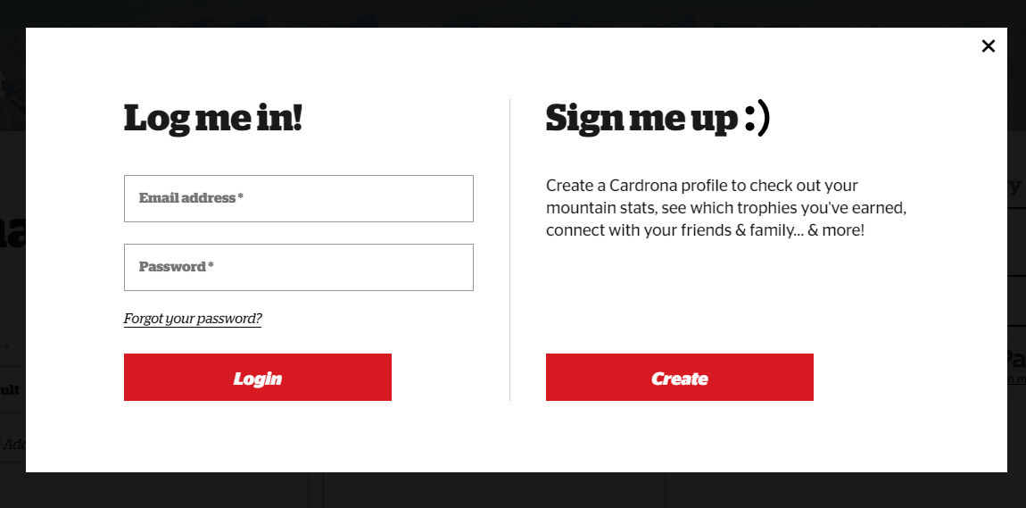
This is the guest portal, NOT the agent portal. Please click back on the agent portal link provided above to return to the correct login screen.
Once logged in, start creating a booking. Type in First name, Last name, DOB and guest email. Make sure to put in guests email and NOT your agent email as this will be used in the guest profile.
DOB is very important as it will auto-fill the correct prices for a child vs adult. When the guest returns, it is easier to find their existing profile with the correct DOB.
If the guest has NEVER been to Cardrona you can add the number on the bottom right of the card into the Link MyCARD field
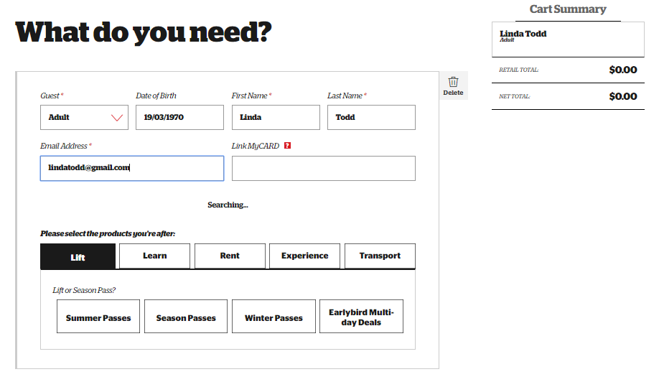
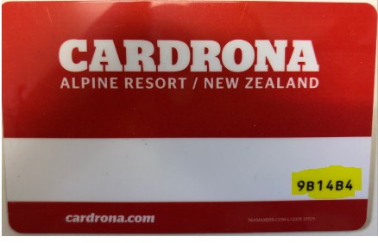
If the guest has been to Cardrona before AND has their lift pass card with them, please leave this blank & link to their existing profile as it prompts you to do so when filling out the correct details.
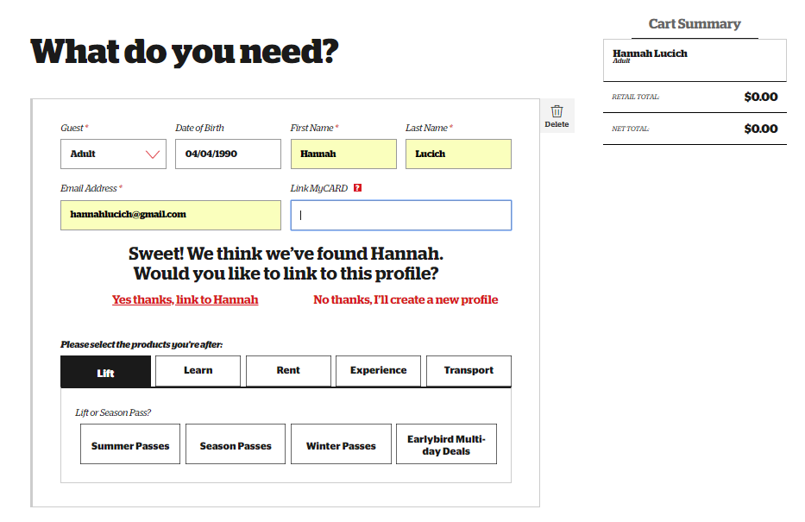
You can also attach their current profile by entering in the 6-digits on the bottom right corner of the card, along with their first & last name.
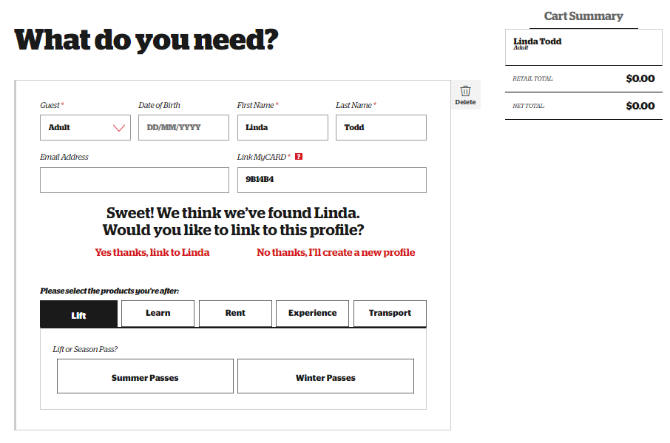
If the guest has been to Cardrona before but does NOT have a lift pass card, then make them a new profile to issue them a red lift pass card.
Next, select the products the guest is after.
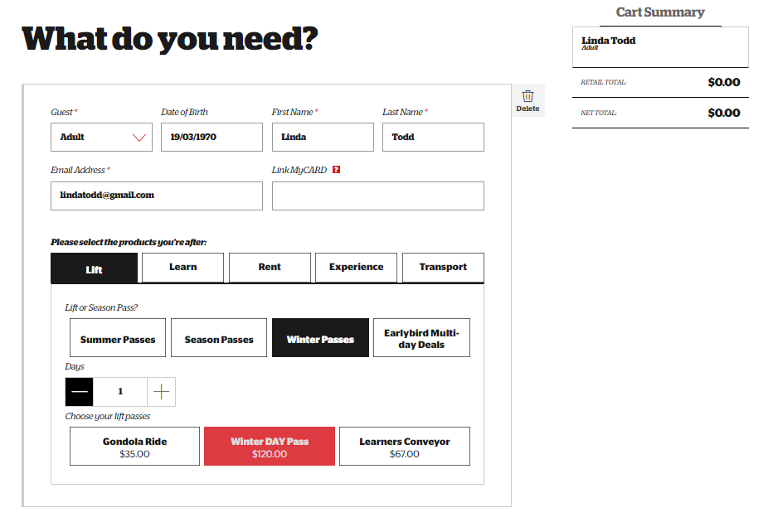
Every guest will need a lift pass to access the lifts to ski/snowboard. Select the Full Day Lift Pass and use the + 1 to add more days depending on how many they plan to head up and click ‘Add to Cart’. For multi-day passes, they do not need to be used consecutive days and will give the guest the best discount if they plan to head up more than one day.
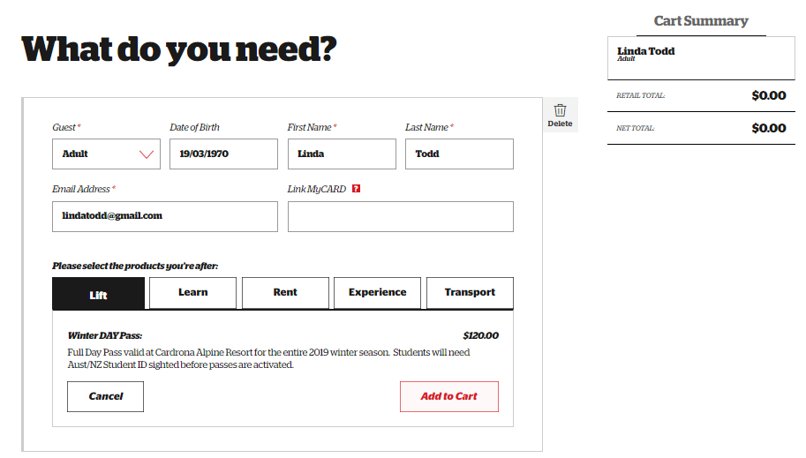
If you sell a guest a student pass, please make sure they know to come visit the ticket office or QT/Wanaka shops to show our reservations staff their valid student ID. If they skip this step then their lift pass card will not scan at the gates.

Continue to select products as you go and they will appear in the right hand cart summary under the guest name. We will start with the learn tab which has all lessons & packages. All first timer packages and group lesson packages are open dated and can be used any day throughout the season. For multi-day packages, they do not need to be consecutive and can also be used any day throughout the season. All packages include lift pass, lesson(s) and rentals. All-inclusive packages include lift pass, lesson(s), rentals & clothing & accessories bundle.

When selecting a ski/snowboard private lesson make sure to put in the correct date for the lesson. Guests can be added to the private lesson at an additional cost, but please make sure they are of similar age and ability.
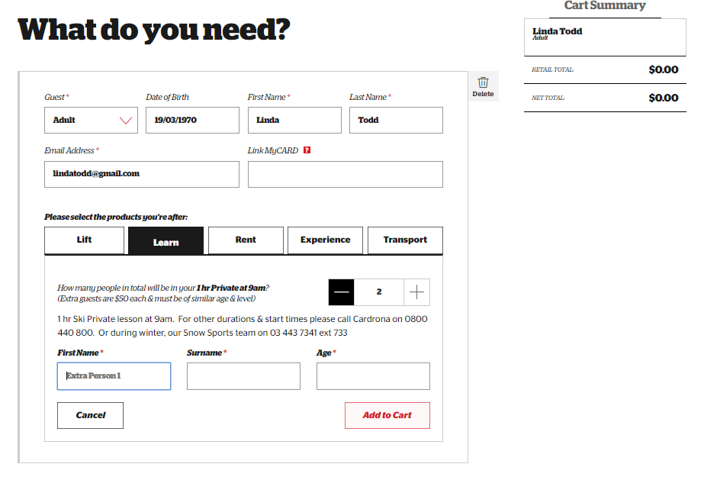
Please make sure to fill out the details including level, and goals for the lesson. If they request a specific instructor, please note that in the details. Please note that the private lesson does not include a lift pass so the guest must purchase a lift pass separately if they don’t already have one.
Under the ‘Rent’ tab, you will find all the rental options including lift pass & rental combo. As you add more days to the rental, it will get cheaper.
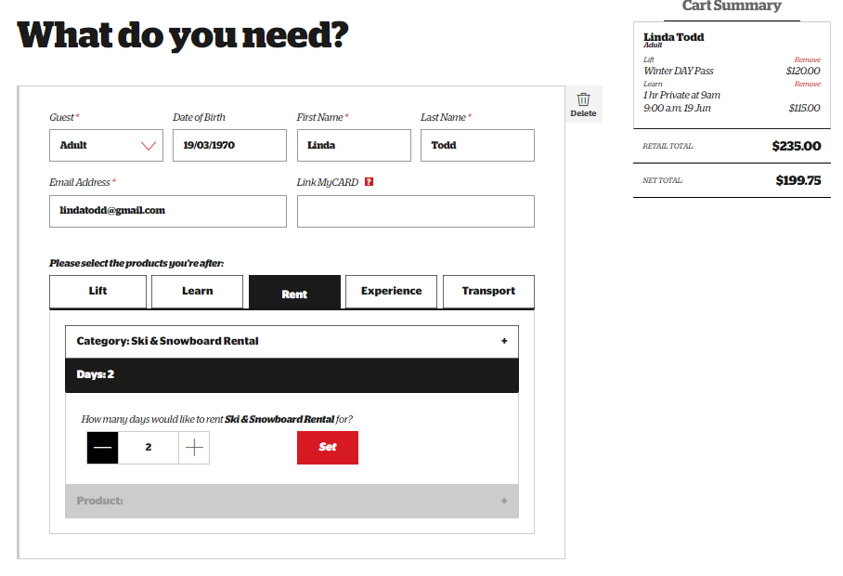
For ski and snowboard rentals, there is an option to fill out some details like boot size, height etc. Don’t worry about filling these out, the guest will do so when they arrive in rentals or to the QT or Wanaka shops.
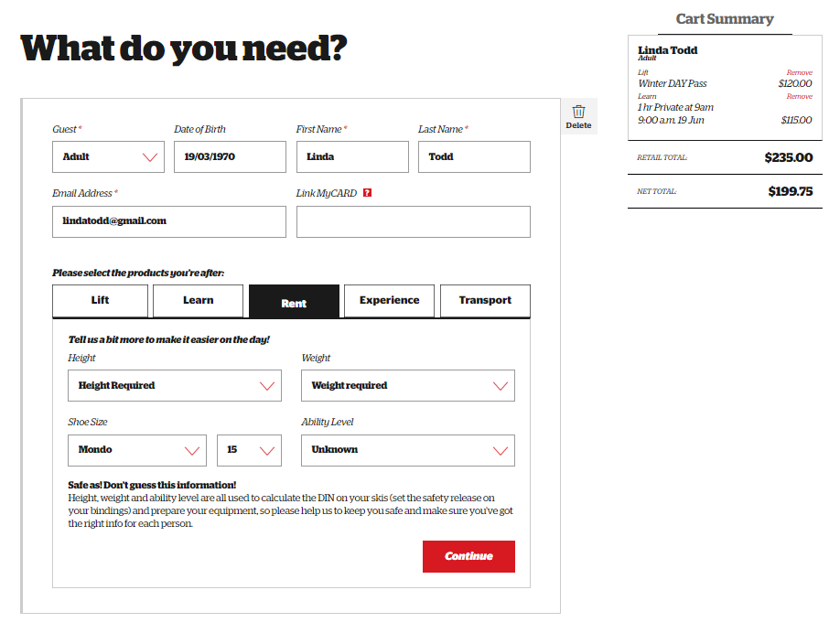
When selecting transport, if you are selling a lift pass or package then it is $30 to add-on transport. Please make sure to select the correct date and location for pickup from the drop-down menu.

Click ‘Add Another Guest’ for additional party members. Fill in their details and products as before.
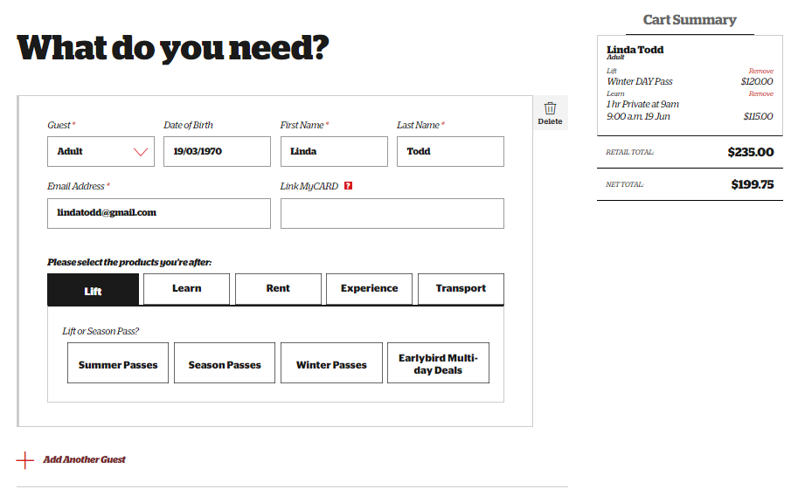
In the below example, Kyle is a child (6-17) so child prices are displayed.
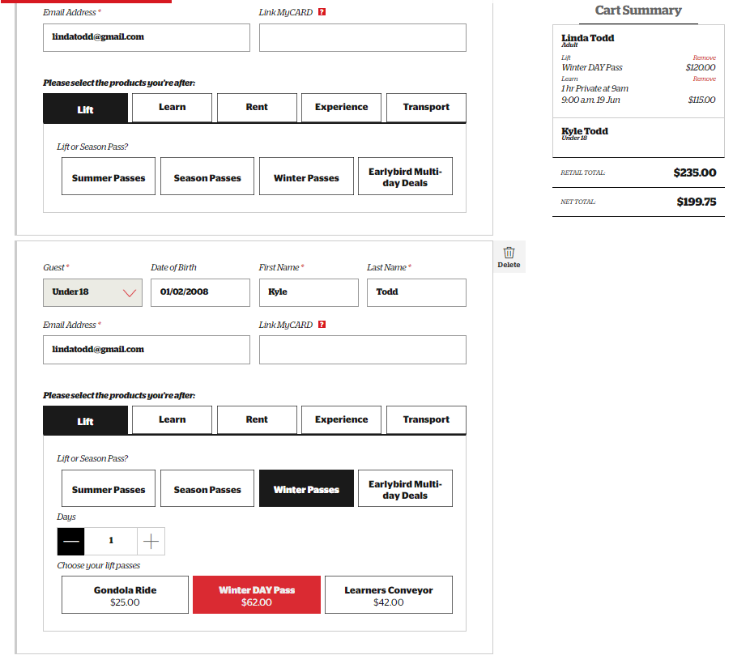
Under the learn tab, you will see our Adventure Programmes (Skiwees & Low riders) added as an option for Kyle.
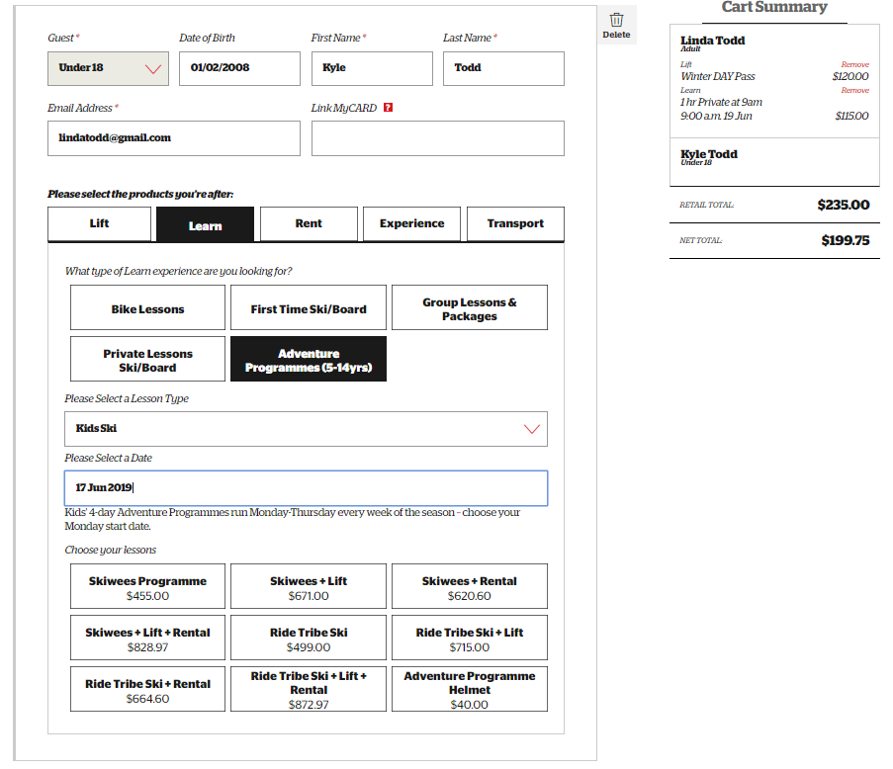
Kids club can be added onto any first timer or full day package. This will only show for children ages 5-14 when putting in the correct DOB.
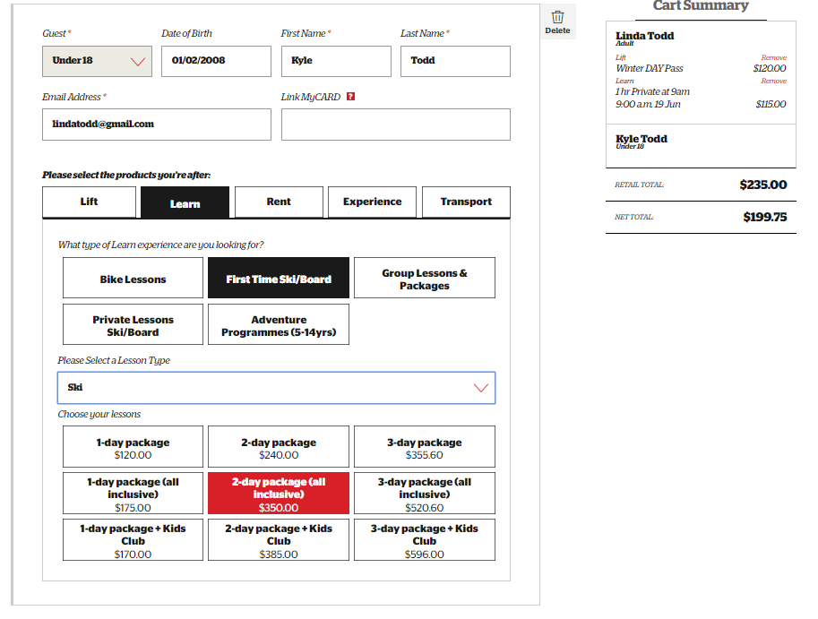
The next guest we add on, Julia is 2 years old. Under 5s receive a free lift pass, but please make sure to load the product into the cart.
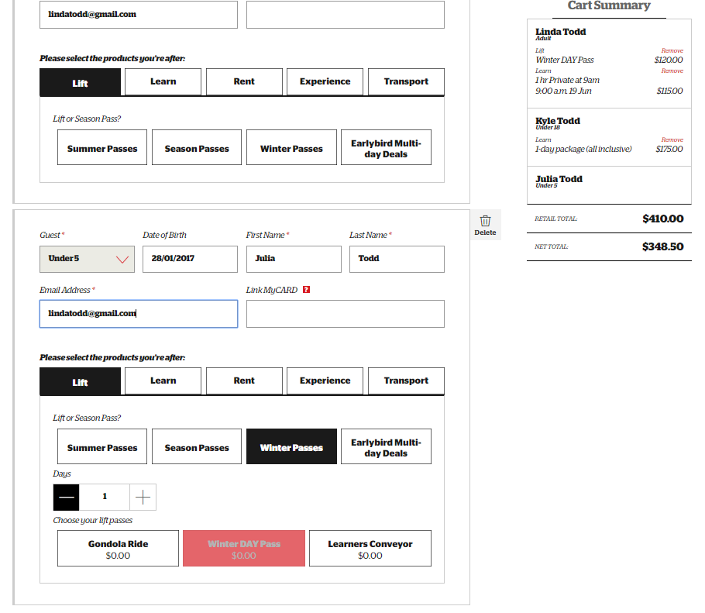
Under the ‘Learn’ tab, the Under 5s products will now be available to book. Ski Kindy (for 2-4 year olds) includes childcare & ski private lessons. Children must be at least 7 years old to learn to snowboard.
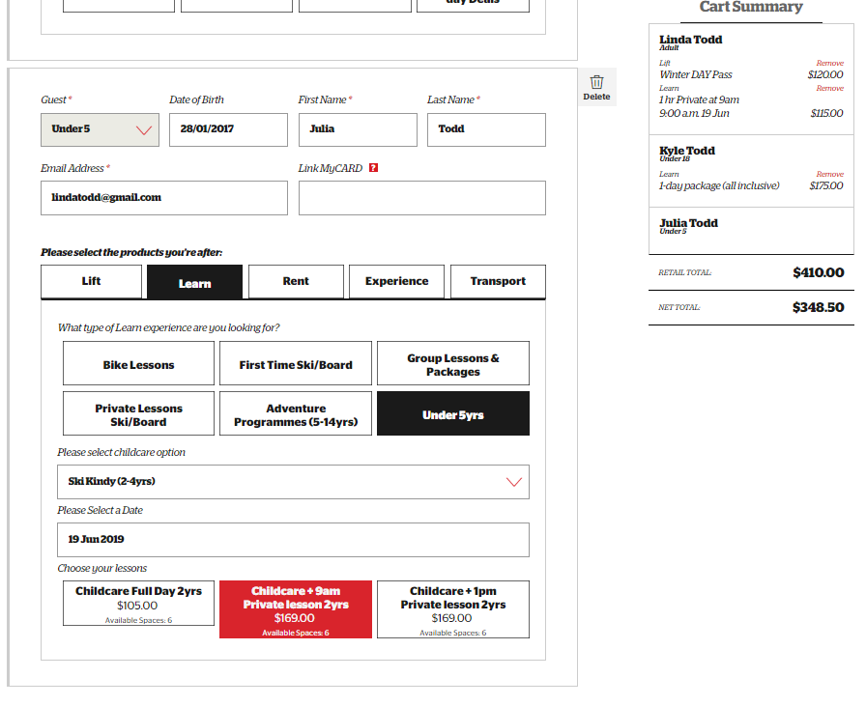
Private lessons for 2-4 year olds are also available on their own.
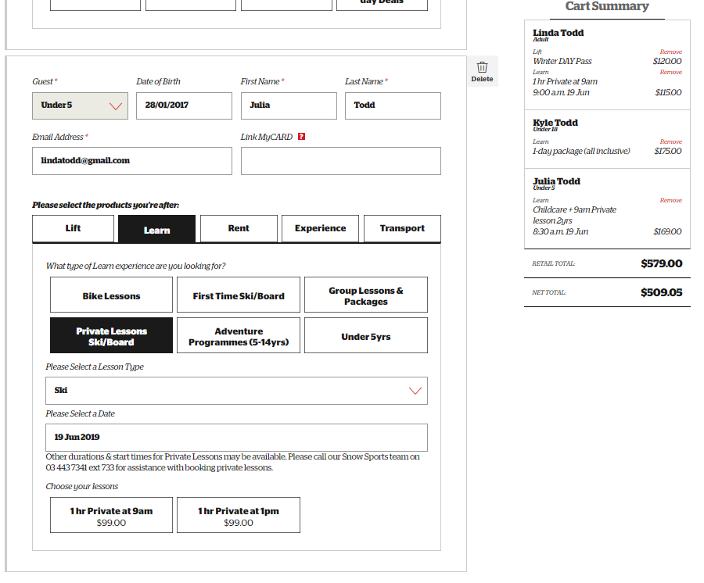
For the little ones under 2 years old, Pengi’s Nursery is available to book.
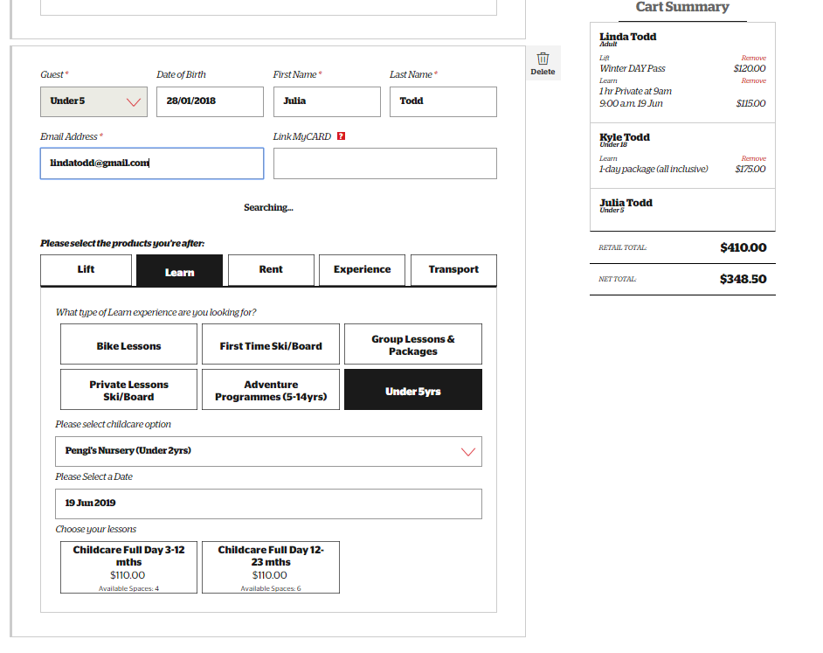
Once you have added in each guest and products press ‘Next’ at the bottom
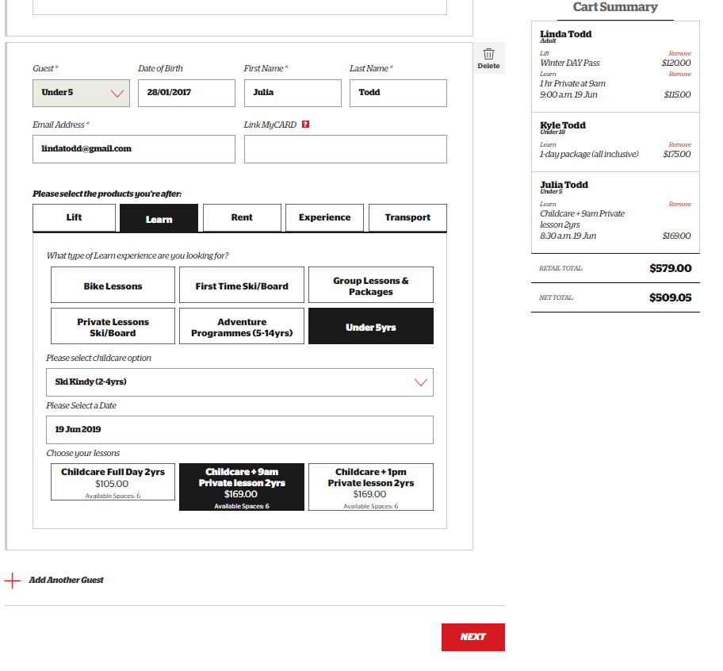
On the cart summary page, make sure everything is correct and tick the T&C’s box at the bottom before clicking ‘Next’
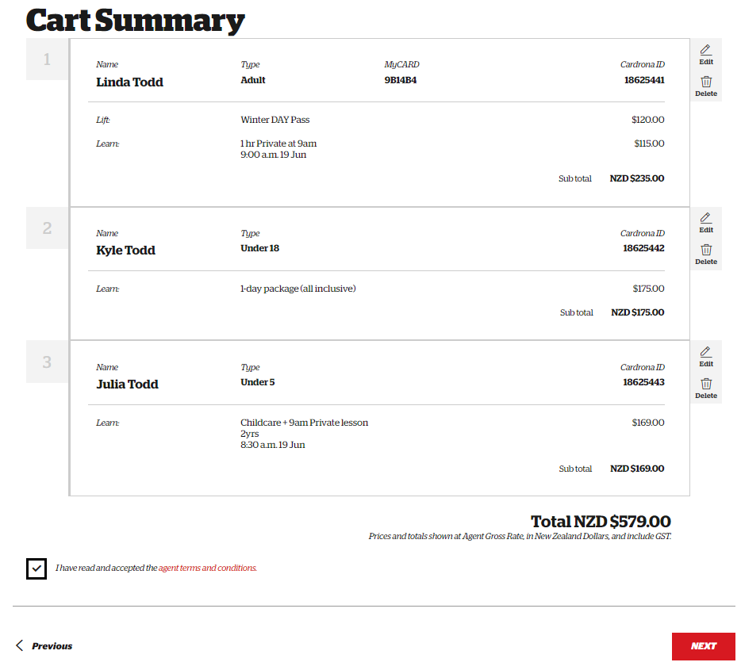
‘Just Quickly’
Party Reference can be entered as the last name of the family or the name of one member of the group.
Confirmation email is one that will automatically be sent an email confirmation of the booking. This is a great place for the agent to put their email in if they need a confirmation as a reference, or a guest email can be used as confirmation of their purchase.
Guest mobile number is required in case of emergency, we only need one per group
You do not have to select Home Location however this is a great way for us to track our stats!
Arrival date is the intended date of travel for the guests. This selection is important as bookings can be edited up until the date of travel.
Agent reference is your own reference number based off what works in your system. For example, a website travel voucher number or IBIS number.
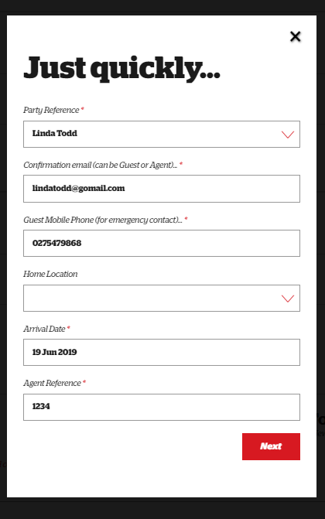
Click ‘Next’
Now you are on the final booking confirmation page
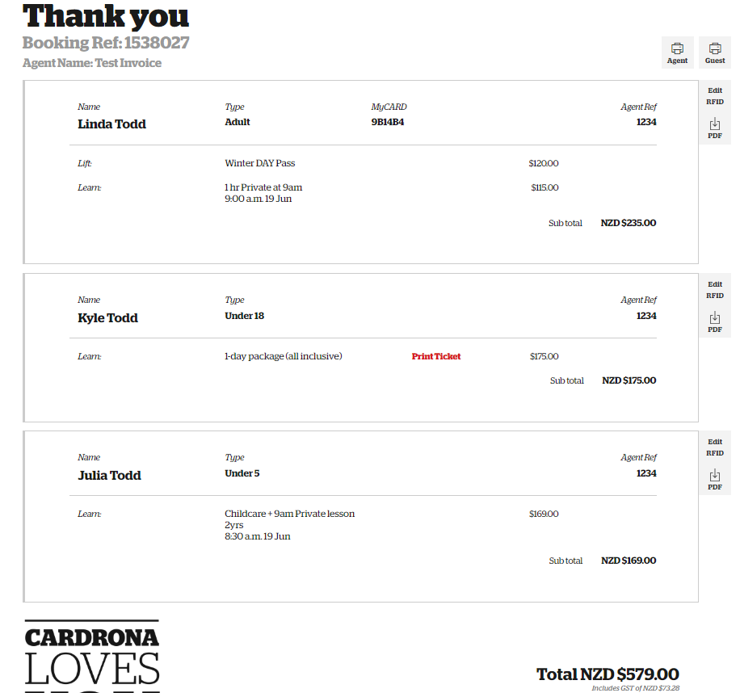
Check to make sure each person has a myCARD attached to their profile. In the above example Linda does but Kyle & Julie do not have a lift pass attached. Click ‘Add RFID’ on the right to add one if this was missed at the start. We want to make sure their card scans when they head to the lifts for the best guest experience.
Where it says ‘Print Ticket’ in red is mandatory lesson tickets you must print out and give to the guest. Click ‘Print Ticket’ and make sure to print for each guest with group lessons.
Booking ref is the number in our booking system. If you need to contact us in regards to a booking you can use this reference or the name on the booking. Call 0800 440 800 to chat with our lovely call centre team
Editing Bookings
To edit a booking, click on ‘Monthly Summary’ at the top menu and choose ‘Date of Booking’ or ‘Date of Departure’
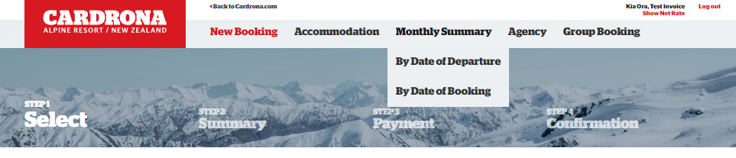
Click ‘View Detail’ for the month you would like to look at
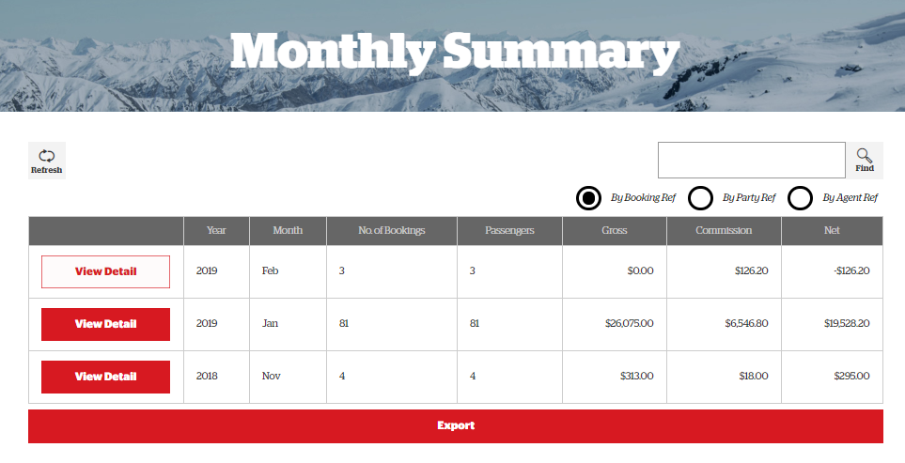
Up until the date of travel, you will see a button on the far right side that says ‘Options’. Click on ‘Options’ and then select the which option you would like to utilise. If the selection is grey, this means that the date of travel has already passed and you cannot make any changes.
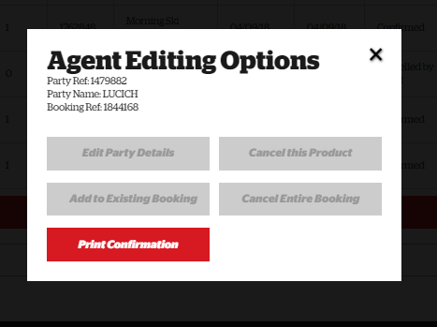
All of our products are non-transferable and non-refundable. Most instances you would not be cancelling products or bookings but adding to existing booking if they forgot to add a helmet or something.

Accommodation Bookings
Select ‘Accommodation’ from the top menu
To check availability & book, select the dates and number of guests
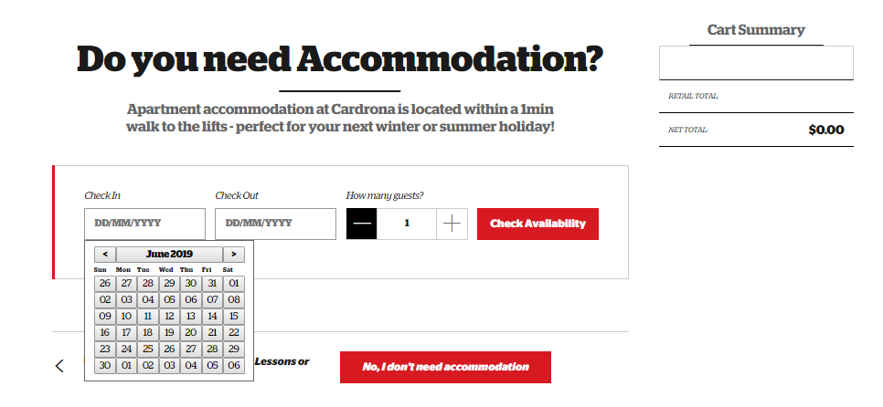
Once you select the dates and number of guests click ‘Check Availability’ and it will pull up a calendar with the availability and prices.
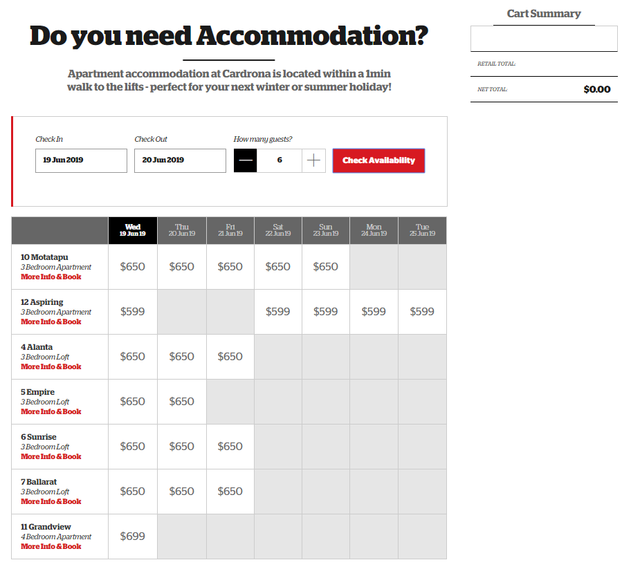
Click on ‘More Info & Book’ or click on the price to get more details about that specific apartment.
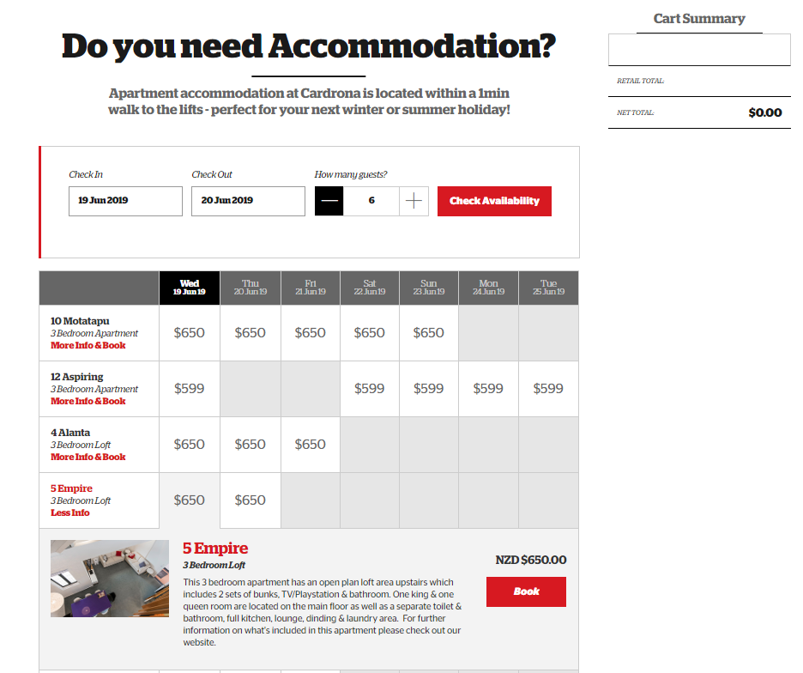
Click on ‘Book’ and it will bring up a screen to fill out more detail.
Some of the apartments can have various bedding configurations. The drop down on bedding layout is to choose which one best suits the guests.
Fill out the first and last name of each guest staying in the apartment.
Under Options, select any if the guests require anything extra or need transfers. If they know their ETA and car rego, fill out those fields.
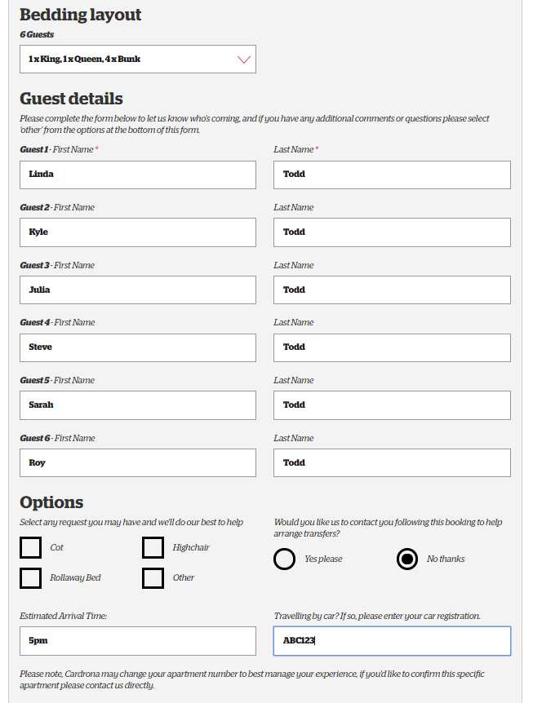
Then click ‘Add to Cart’
If they would like to add another apartment booking, click ‘yes’ and if not then just click ‘No, skip this’ or select ‘Next’
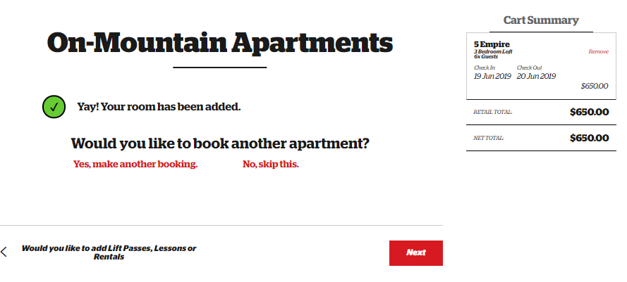
On the cart summary page, we have the confirmation screen where you can check to make sure all the guests’ details are correct. Make sure to tick the T&Cs box then click ‘Next’
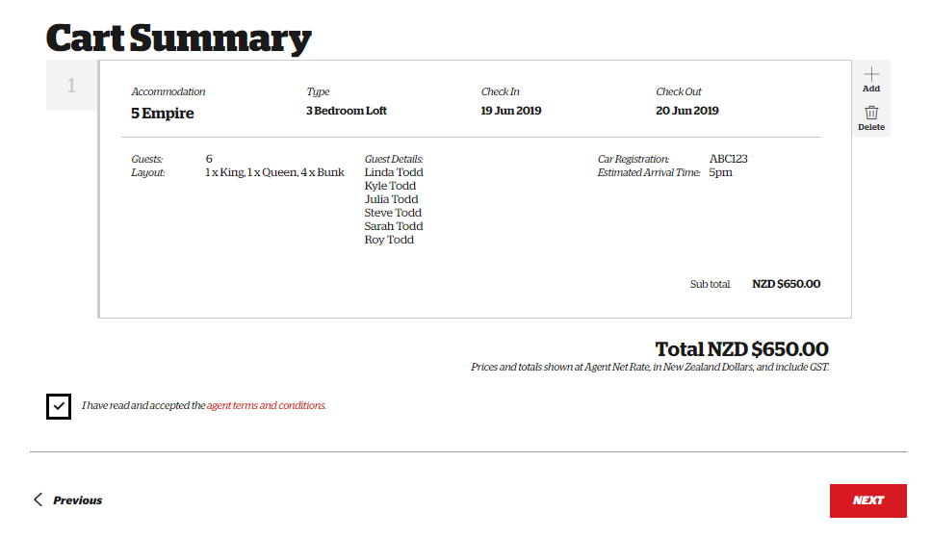
Just quickly…
Party reference is the last name of the group or one person in the group
Confirmation email is where you put the guests email as they will automatically be sent a confirmation with their apartment booking.
Please add a guest mobile number so our apartments team can contact them directly
Home Location is not a required field (if you fill it out, it may ask for region).
Arrival date is the date the guest will check in to the apartment
Agent reference is your own reference number based off what works in your system. For example, a Website Travel voucher number or IBIS number.
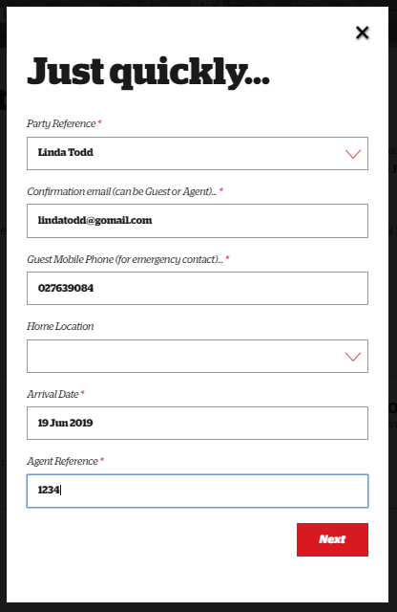
Click ‘Next’ and you have now completed the accommodation booking. If you have any questions or need to change anything, please phone our call centre at 0800 440 800 or email apartments@cardrona.com
